NH TREE FARM MANAGEMENT PLAN
SHERBURNE FOREST
70 ACRES
Prepared For:
Name: Town of New Boston
Address: 7 Meetinghouse Hill Rd.
PO Box 250
New Boston, NH 03070
Phone: (603) 487-2500
Prepared by Thomas Miller
New Boston Forestry Committee

The following plan outline has been formatted to assist the New Boston Forestry Committee in preparing an acceptable Tree Farm Plan to include the 2010-2015 Standards of Sustainability for Forest Certification.

__________________________________________ _________________________________
Signature NBFC Representative Signature Hillsborough County UNH
Extension Forester
____________________________________ _____________________________
Date Date

Sherburne Forest Management Plan

Table of Contents

- Introduction …………………………………………………………………………… page 1
- Location…………………………………………………………………………………… page 2
- Description……………………………………………………………………………… page 2
- History…………………………………………………………………………………… page 3
- Piscataquog Land Conservancy Conservation Easement/New Boston Forestry Committee Management Goals……………………………………………………………….. page 4
- Invasive Species…………………………………………………………………… page 6
- Natural Communities…………………………………………………………… page 7
- Educational/Recreational……………………………………………………… page 7
- Boundary Lines……………………………………………………………………. page 8
- Forest Health………………………………………………………………………. page 9
- Wildlife Zone Management…………………………………………………… page 11
- General Guidelines………………………………………………………………… page 19
- Forest Management Activity Schedule…………………………………… page 20
- Soils………………………………………………………………………………………. page 20
- Forest Stand Data…………………………………………………………………… page 22

Appendices
- Sample Plot GPS Coordinates
- Sample Plot Map and Forest Stands Map
- Wildlife Zone Map
- Trail Map
- New Hampshire Heritage Bureau Report
INTRODUCTION

This Forest Management Plan is for use as a guide by the New Boston Forestry Committee. The plan reflects the objectives of the New Boston Forestry Committee (NBFC) at the time of the preparation of the plan in 2019. When changes in site condition, objectives of the NBFC, or committee goals occur, the plan shall be reviewed and amended as appropriate. Requirements shall be reviewed and amended as needed in order to fulfill requirements for the NH Tree Farm status.

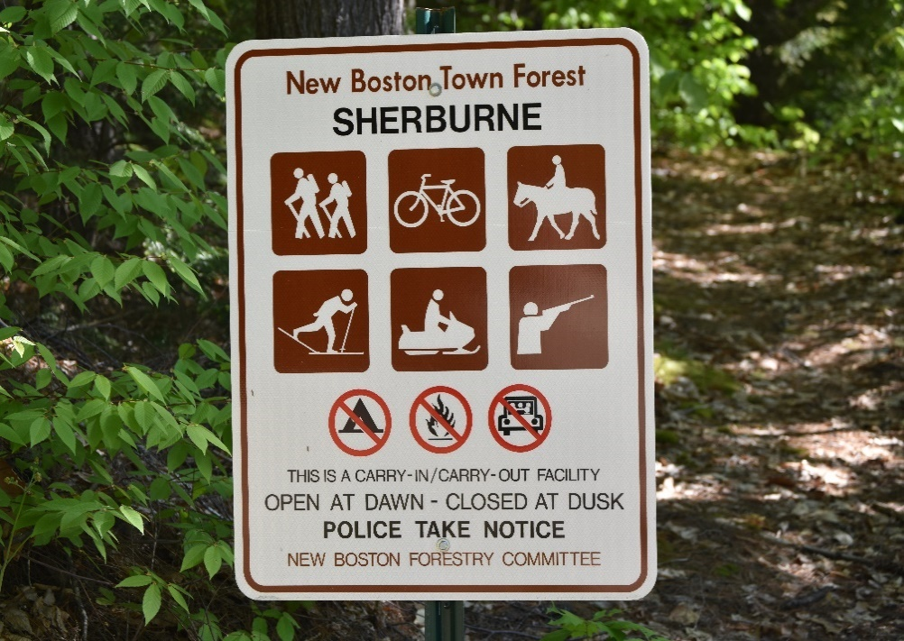

LOCATION

The Sherburne Forest is the property of the Town of New Boston, New Hampshire. The property is managed by the New Boston Forestry Committee (NBFC). The tax map number of the property is 7-22 with a contiguous area of 70 acres.
Sherburne Forest is a multi-use property. It is used by the New Boston Highway Department (NBHD) for minerals (sand) taken from the lot for highway use in town and is used for recreation, including walking, hiking and horseback riding. In addition, the land is managed by the NBFC for quality wildlife habitats, wetland protection and forestry purposes.
The Sherburne Forest is located on Cochran Hill Rd., a class VI road. This section of Cochran Hill Rd. is located on the north side of Old Coach Rd., in the Town of New Boston. Access to the property is through a parking area along Cochran Hill Road.

DESCRIPTION

This Town Forest has two distinct ecological areas east and west of the wetland. The middle of the forest consists of a small stream with a large expanse of wetlands, which drains into the South Branch Piscataquog River. The stream that passes through the middle of the forest has a series of old and new beaver dams. The east side of the forest drops off steeply to the west into the wetland. There are piles of glacial erratics in areas at the highest points. The dominant forest species in this area is Hemlock with a mix of White Pine, Beech and Red Maple.
The west side of the forest is in part an esker (Kame Terrace) covering 17 acres with a steep drop off to the east into the wetland. The esker is a deposit of sand that is currently being

mined by the New Boston Highway Department (NBHD). The dominant forest species is White Pine with a mix of Red Maple, Hemlock, Beech and Red Oak.

HISTORY
The history of Sherburne forest is much like other forests in the State of New Hampshire, starting with colonial families in the 18th century and ending with forests that reclaimed old agricultural fields. The known history of this forest begins with a cellar hole which records show belonged to the Clark Family. The family occupied the site in the 1770’s. There is also a stone three-sided foundation close to the cellar hole that may have been used by the same family for unknown purposes. As is the case for much of New Boston in the 1700 to 1900’s, the land was used for agricultural purposes, evident by the numerous stone walls that remain on the property.
The Sherburne Family owned the land from the early 1900’s until November 13, 2000. In 1997, a timber harvest was conducted with the removal of all but a few of the marketable trees. Most of the White Pine left on the lot show signs of White Pine Weevil damage and are of poor timber value as a result. There are a few large Red Oak and Hemlock left on the property.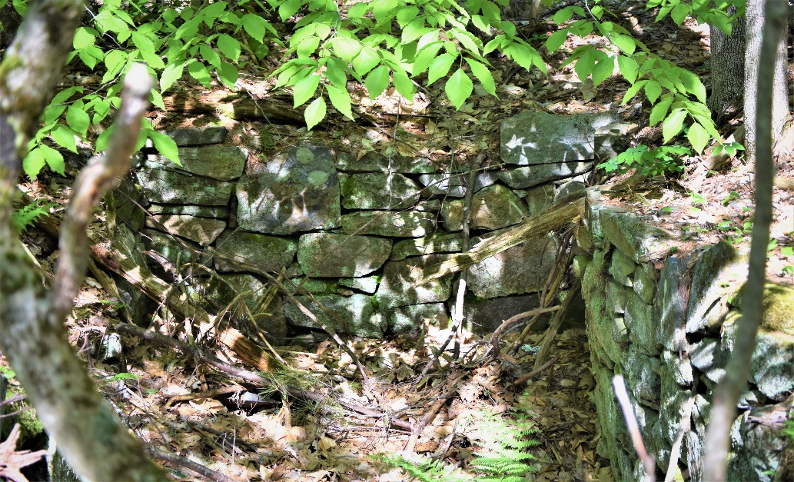
Clark Family Cellar Hole – East to West View

The Town of New Boston purchased the land on 11/13/2000 for the sum of $150,000. The main reasons for the land purchase were to obtain the sand as a resource for the town highway department and to protect the large area of wetlands. The NBFC assisted in the establishment of buffer zones around the esker and assisted financially in the purchase of the land.
In 2001, UNH students (HR 775) conducted a natural resource inventory and made recommendations for land use around 2002. Recommendations are as follows:
- Maintain the forest as a greenspace
- The forest is not to be used for athletic fields
- Remove all debris
- Construct a bridge where the trail crosses the brook
- Consider a possible timber sale in 15-20 years
- Timber Stand Improvement (TSI) work on White Pine (pruning)
- Finish trail system to the southernmost point
- Create a covered pavilion near the wetland
- Create and open the forest to educational opportunities and make signs
10) Protect the wetlands

The NBFC completed construction of the existing trail system around 2002. The trail bridge over the stream was built in 2013 by an Eagle Scout from the Town of Goffstown in fulfillment of requirements for the Eagle Scout Project. Other volunteers from New Boston Scout Troop 123 assisted with clearing brush to create the trail east of the wetland.

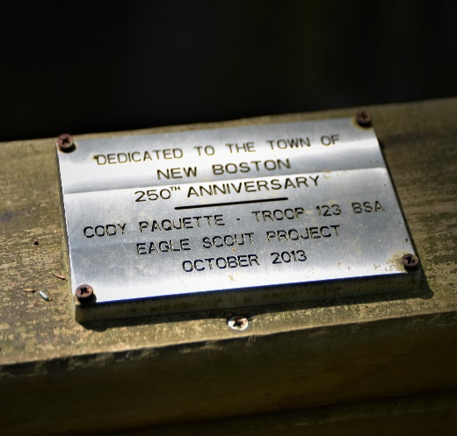
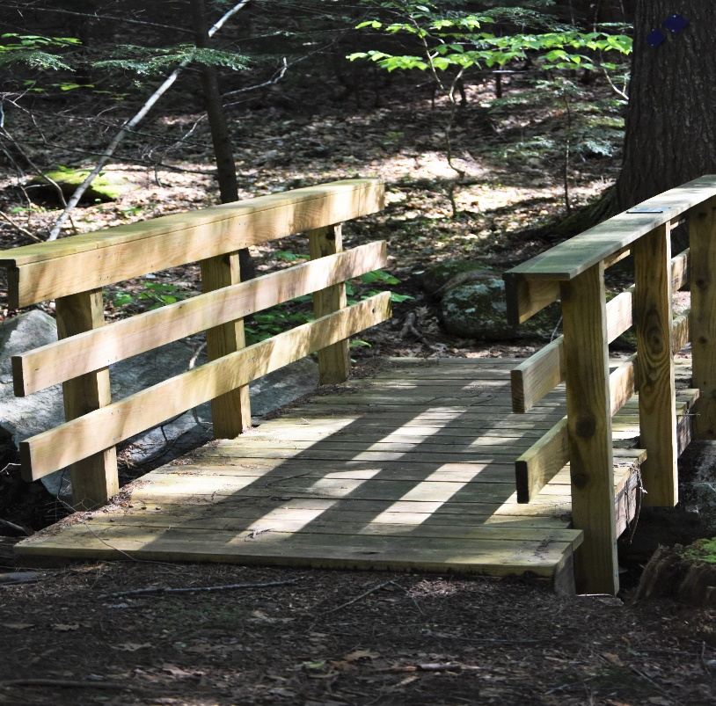
Trail Bridge Completed by Eagle Scout

Piscataquog Land Conservancy Conservation Easement
In April of 2021, a conservation easement was placed on the Sherburne Forest. The Piscataquog Land Conservancy is the holder of the easement. Together with the PLC, the NBFC will work to preserve the soil and water quality, forest and wildlife diversity and habitat, natural communities, historical and scenic qualities of the property. The conservation easement ensures that the property is protected in perpetuity by utilizing the most up to date best management practices for all forestry and recreational related activity.
NEW BOSTON FORESTRY COMMITTEE MANAGEMENT GOALS
Based on NBFC evaluation of the property, the NBFC has chosen to manage the Sherburne Forest for wildlife habitat, water quality and recreation uses. The Sherburne Forest is part of a large wildlife corridor that includes Lydia Dodge Town Forest, Bob Todd Town Forest, Wheeler Conservation Land and Kachavos Conservation Land. The latter two parcels are managed by the Piscataquog Land Conservancy.
“The importance of a wildlife corridor is for genetic exchange of the same species to maintain health and vigor of animal populations.” (UNH Ext. Winter Bulletin 1991)

Though there will be no large-scale harvesting operations on this property, the NBFC will utilize the following documents for any forestry related activities; “Good Forestry in the Granite State: Forestry Management for NH” (NHDRED, Dec. 2010), and “New Hampshire Best Management Practices for Erosion Control On Timber Harvesting Operations” (Division of Forests & Lands, & University of NH Cooperative Extension. Dec, 2016). “Uneven-Aged Management of Northern Hardwoods in New England” (Leak, W. and Filip, S. USDA Forest Service Research Paper NH-332, 1975) will be consulted as well.

Forest products from the Sherburne Forest will be the byproduct of wildlife habitat management. The following are reasons why timber management is limited:

- There is a large wetland running through the middle of the forest, which makes the placement of skid trails difficult.
- There is a buffer zone around the NBHD mining operation on the Kame Terrace, which is restricted from harvest.
- An extensive hiking trail system exists in the forest and the NBFC does not wish to disturb or remove these trails.
- Due to the wetlands bisecting the middle area and private land surrounding the east side boundary, there is no access to the eastern side of this forest for logging equipment.

The Sherburne Forest will be managed for four (4) distinct wildlife zones resulting in unique management areas. More information about the habitat provided by these wildlife zones is available from “Landowners Guide to Wildlife Habitat” by W. Leak, A. Lester, R. Degaff, M. Yamaski.
The wildlife zones identified by the NBFC are wetlands, old growth forest, wildflower pollinator field and uneven age upland hardwood forest. Management of these different eco-systems will help to ensure wildlife species diversity.

INVASIVE SPECIES
There is a small area around the Clark Family cellar hole where Oriental Bittersweet has been identified. The forested area where the Bittersweet was found is within the no-cut buffer zone around the NBHD mining area. This placement is somewhat beneficial, as the lack of harvesting in this area will limit the amount of sunshine that can reach the forest floor. Lack of sunlight will in turn limit the growth and spread of invasive species. Removal of the invasive Bittersweet plants, either by hand or with a small excavator, will be helpful in stopping the spread of
bittersweet. If volunteers are available to perform the removal, the NBFC will organize a workday to remove the plants. The use of herbicides is not recommended by the NBFC because of the proximity to the wetlands. There does not appear to be any other area in this forest where invasive species exist at the present time.

NATURAL COMMUNITIES
There are no endangered species reports at this time, as reported by the New Hampshire Natural Heritage Bureau. (See Appendix report)
NH Natural Heritage Book “The Nature of NH” by Dan Sperduto and Ben Kimball, classifies all ecosystems in NH into distinct Natural Communities. According to the NBFC’s evaluation of the property and consultation of Sperduto and Kimball’s book, the wetlands of the Shurburne Forest are a mix of Tall and Short Graminoid Shrub-Shrub Marsh and Forb Meadow Marsh (both ranked S4 – fairly low risk of extinction). Uplands are Hemlock-White Pine- Oak forest (S4).

EDUCATIONAL AND RECREATIONAL

The Sherburne Forest is a resource which should be utilized by the New Boston school system for educational purposes. The forest’s various wildlife habitats, diverse plant species and eco-systems could help provide hands-on experiential education for students.
Recreational trails run throughout the forest. The bridge at the southernmost part of the trail is a single felled tree and could be improved to a more permanent structure. Recreational uses include hiking, biking, cross-country skiing, snowshoeing, horseback riding, wildlife viewing and general enjoyment of the aesthetics of this forest. Wheeled motorized vehicles are not permitted in this forest. The trail system covers many parts of the forest and offers very diverse forest and geology, as previously identified.

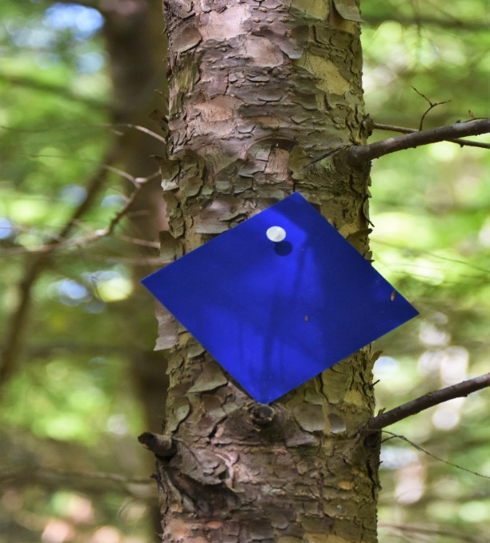
Trail Marker

BOUNDARY LINES

All sides of this forest are marked by aluminum 2 ½” x 2 ½” printed signs bearing the NBFC logo and name. Boundary line maintenance should be performed on a bi-annual basis.

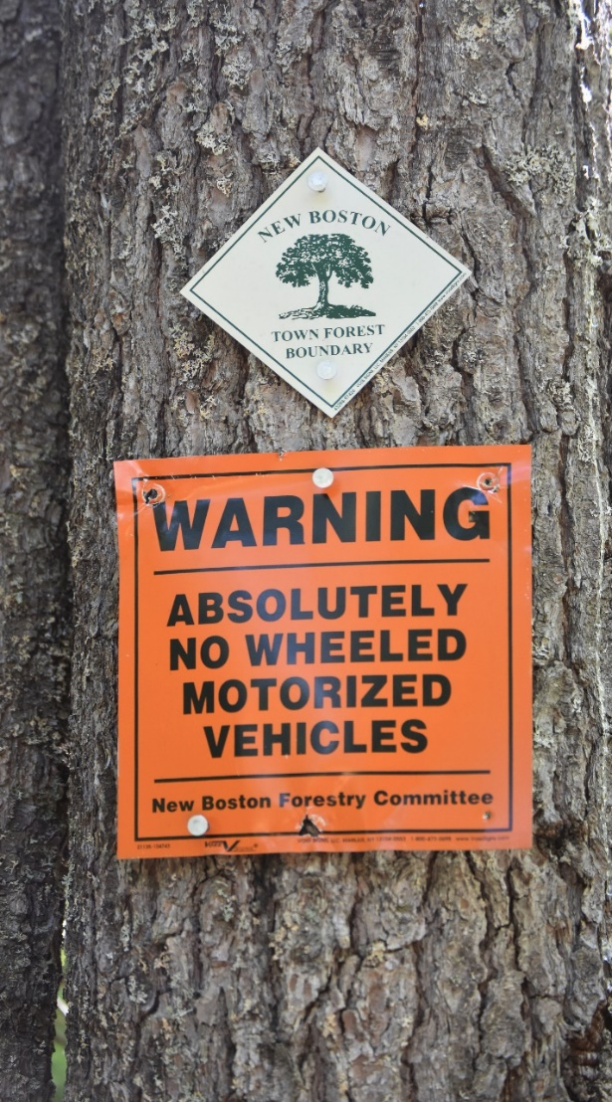 Boundary Marker

FOREST HEALTH

The Beech trees in the Sherburne Forest show signs of Beech Bark Disease. Beech trees will succumb to this disease over time. As a result of Beech Bark Disease, the Beech trees will produce few Beech nuts over time, limiting their usefulness as a food source for wildlife.
Hemlock Wooly Adelgid and Elongate Hemlock Scale are pests that are found in New Boston forests though the Sherburne Forest shows no signs of the pests at this time. The largest concentration of Hemlock trees is on the east side of the wetland where there is no forest management access. If this stand of Hemlock is attacked by the above pests, the NBFC must

determine an appropriate course of action. The USDA publication, “Managing Hemlock in Northern New England Forests Threatened by Hemlock Wooly Adelgid and Elongate Hemlock Scale” (9/2015) shall be consulted as a guide for management. Should this threat kill off the Hemlock, other successional trees, like White Pine, Red Maple, Aspen, Red Oak or White Birch will fill in the areas left behind creating a new habitat and food sources for wildlife. In order to ensure that other tree species are available in case of significant Hemlock decline, non -Hemlock species will be favored where possible during wildlife habitat management operations.

The Emerald Ash Borer is also found throughout New Boston. This invasive insect kills 100% of ash trees once it infests an area. There are very few White Ash trees found in the Sherburne Forest. The Emerald Ash Borer will kill these few trees over time, leaving small areas in the forest floor for other species to develop.
Due to the proximity of this forest to major wetlands, the use of pesticides to control disease and invasive insects is not an option.
Other forest health concerns may occur over time. Early detection and rapid response to these issues is important to successful management.
Monitoring the health of the Sherburne Town Forest shall be completed by the NBFC annually.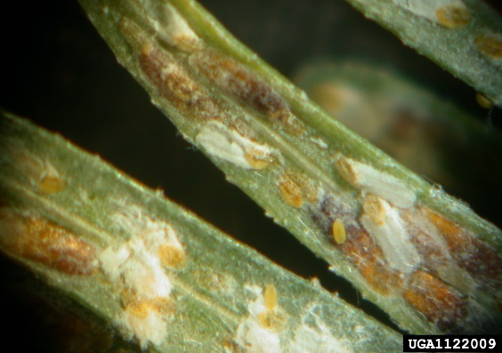 Eastern Hemlock Elongate Scale

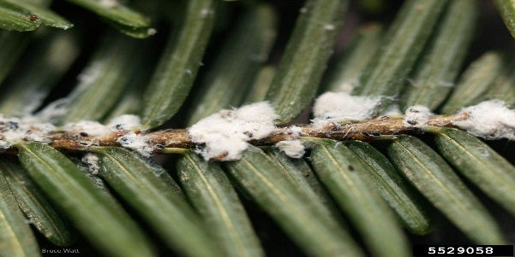 Hemlock Wooly Adelgid

SHERBURNE FOREST WILDLIFE MANAGEMENT ZONES
Zone #1 – Old Growth

This area is located on the east side of the wetland and is 27 +/- acres. It contains forest stand #1, stand #2 and stand #3. (See index for map) There is no access to this zone, because of the wetlands and private property to the east. The NBFC recommendation is to let this area grow without any silvicultural practices.

This old growth forest stand will limit light reaching the forest floor, thus allowing only shade tolerant species to survive, such as beech, Hemlock and Maple. Small openings caused by blow downs and dying trees will allow small areas of regeneration for shade tolerant species.

Leaving trees to grow to maturity and beyond will benefit many distinct mammal and bird species. If the forest continues to transition toward dense Hemlock, it may serve as a White-tailed Deer wintering area. Downed rotten logs and snags in this area are utilized for cover by insects and reptiles, and for feeding habitat by insectivorous birds. Cavity trees in this zone are necessary and used by a variety of wildlife species for nesting, shelter, and denning sites. These

cavities are used by species such as barred owls, woodpeckers, nuthatches, wrens, wood ducks, chickadees, squirrels, porcupine, bats, fox and fisher. There is now an average of 2 cavity trees per acre, 12” + DBH, in this zone at the present. As time passes, this average is expected to increase as the existing trees mature.
There is a small population of what is likely Snowshoe Hares noted during the forest inventory in the winter of 2019. The habitat is ideal for hares with a low, dense cover of conifers and areas of understory with small successional mixed hardwoods. The edge of the wetland has a grass matrix, ideal for hare. American Woodcock require the same forest conditions and may be using the environment also.
The zone contains glacial erratics used as denning sites for mammals such as fox, porcupines, bear and coyotes.

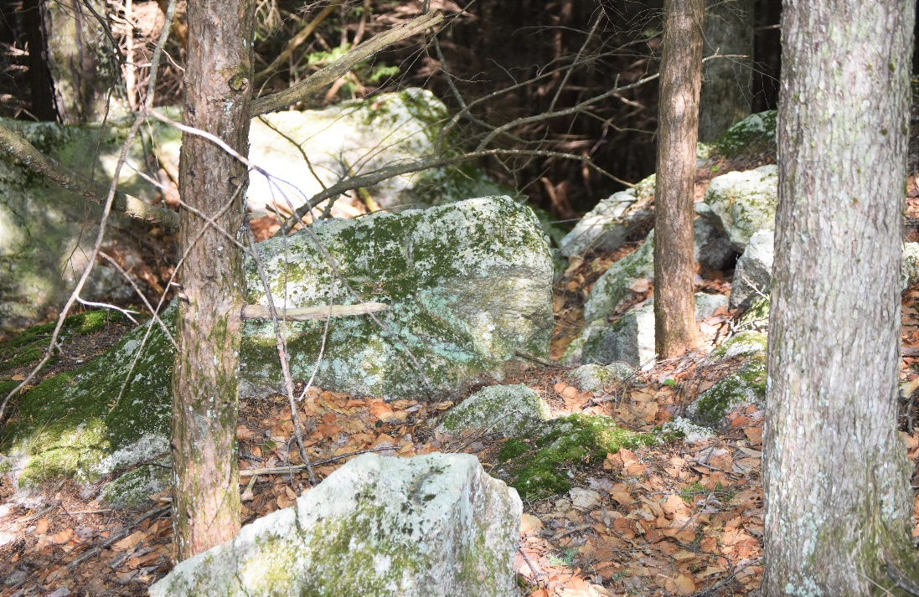
Glacial Erratics

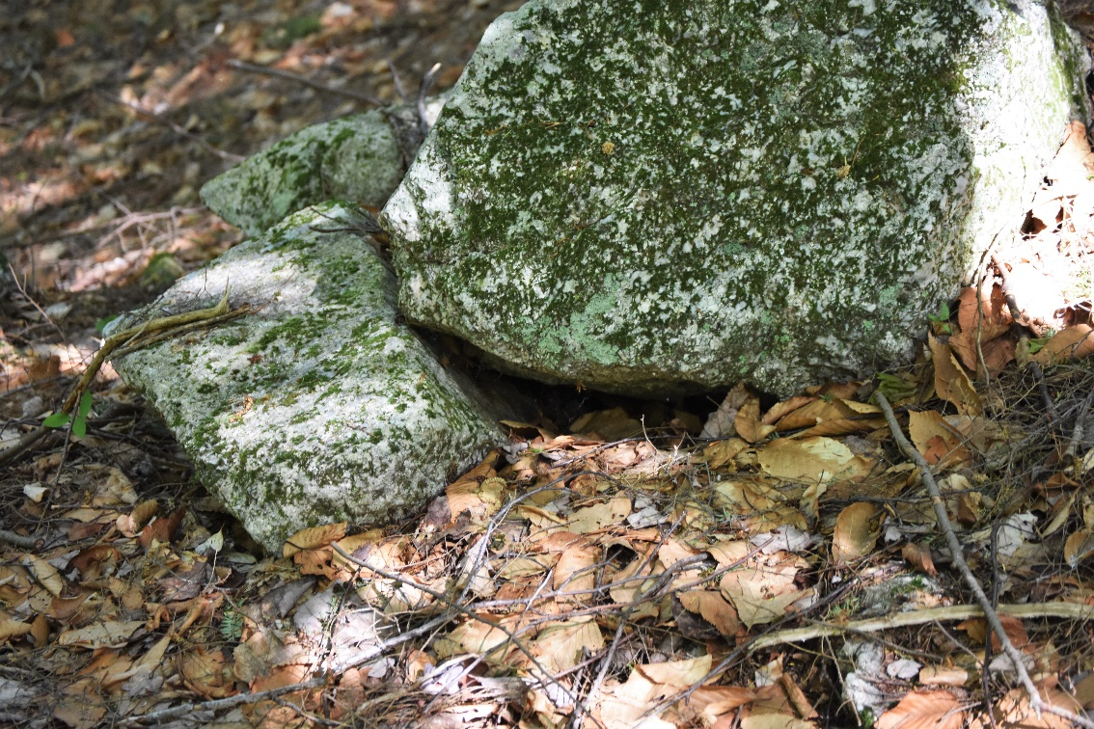
Denning site for Small Mammals

There are a few Red Oaks of the size 16”-28” DBH in this zone. These trees can yield over 10 lbs. of acorns per tree during “mast years” where the trees increase seed production. These high -volume seed crops are estimated to occur every 2-5 years. Acorns are a very important feed crop for mammals and birds, such as White-tailed Deer, Turkey, Black Bear and Wood Ducks. The are other feed crop trees in this zone include Red Maple, Beech, Black Oak and Ash.

Vernal pools exist in this zone, in limited size and numbers. The pools offer important habitat for many amphibian and reptile species. Vernal pools are critical breeding habitat for wood turtles, salamanders and other amphibians and retile species. Vernal pools also provide moisture and forage for wildlife.

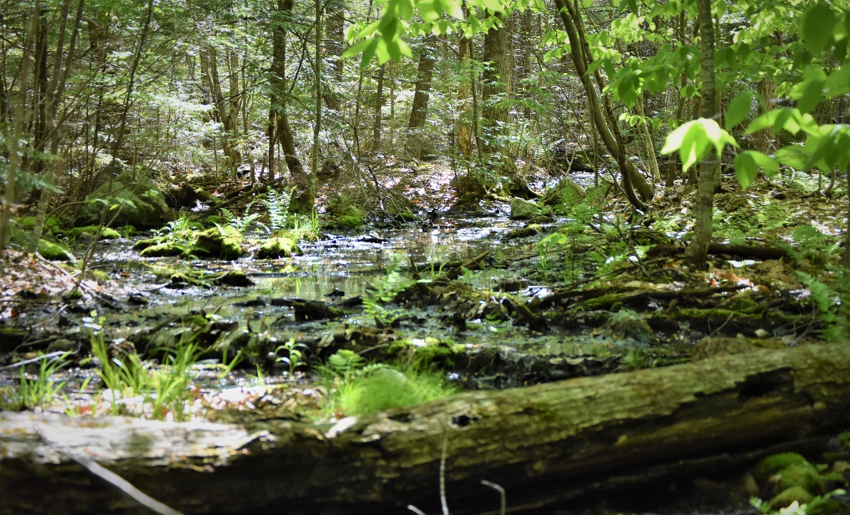

ZONE 2 - WETLAND
The wetland zone runs through the center of the Sherburne Forest from north to south and is 9+/- acres in size. The zone contains a small stream, running north to south, that is approximately 2’ – 4’ wide. This stream has been dammed up many times over the years by beavers. The remnants of the old dams are visible along the length of the stream. The damming of the steam by the beaver is an important environmental benefit to this zone. The dams create sedge meadows and marshes. These ecological areas are home to frogs, box turtles, spotted turtles, snakes, sparrows, finches, wrens, ducks, herons, minks, muskrats, raccoons, moles, mice and Eastern Cottontail, among other species.

The newest dam is in the southern most section of Zone #2, with a 3’ +/-foot high dam, creating a flooded area of about 2.5 acres. The sedge meadow, created by old beaver dams which had flooded the area and are now breached, has high-bush blueberries, alders and related marsh growth is a unique and diverse habitat.
The edges of the now breached beaver pond impoundment are becoming early successional forest with a dense cover of conifers like White Pine, Hemlock. The habitat produced by this early successional forest is beneficial to the following wildlife: hares, wood turtles, box turtles, woodcock, green snakes, whip poor wills, bob white, indigo buntings, to name a few species.
The wetland zone has a trail that follows along its edge on the east and south side. The hiking trail is of aesthetic value and has wildlife viewing opportunities that are an asset to the Town of New Boston residents.

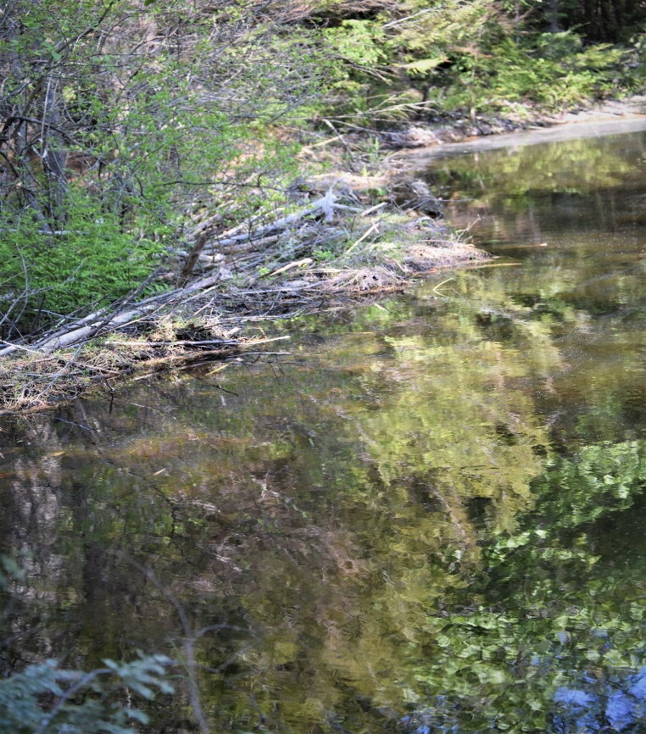New Beaver Dam

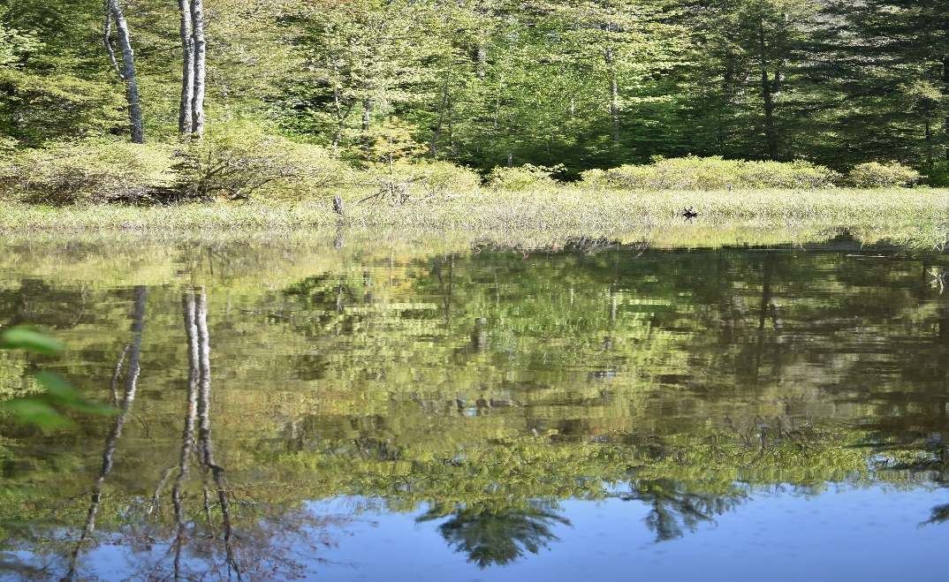 Beaver Water Impoundment

ZONE #3 – WILDFLOWER MEADOW

The Wildflower zone, which cover 17+/- acres, is located on the west side of the wetland and east of Cochran Hill Rd. This area is known as the Kame Terrace. There is a buffer zone around the mining area. The buffer zone limits viewing of the mining operation from Friendly Beaver Campground, Cochran Hill Rd. and the wetland. No trees shall be cut in the mined area buffer zone. The sand pit is estimated to be +/- 10 acres. The buffer zone is 50’ from the wetland and Cochran Hill Rd. and 200’ in front of the Friendly Beaver Campground, the neighboring parcel.

At the March 2019 meeting NBFC recommended that the new buffer zone be 50’ from the highest point on Kame Terrace along its north, south and east sides. The new buffer zone on sand pit excavation will limit erosion and minimize windthrow of standing trees on the Kame Terrace steep slope to the wetland.
After the sand pit supply has been exhausted, the area is to be reclaimed using existing topsoil.

Topsoil shall be spread over the disturbed area. Topsoil is not to be spread within three feet of the existing forest soil, leaving a buffer zone of exposed sand. This practice will create nesting areas for turtles, which require loose, sandy soil to be able to dig nest sites. Following the spread of topsoil, the sand pit area is to be seeded with a wildflower mix to promote development of habitat for native pollinators, birds and mammals. The slopes are to be seeded with Birdsfoot Trefoil, while the flat areas will be seeded with a mix of wildflower seeds to be determined based on their value to pollinators and their cost at the time of seeding. A hydro seeder is to be used because of the size of the area to be seeded. The wildflower zone is to be mowed annually to stop forest succession from taking over the area. Mowing will be as late in the fall as practical to maximize the benefit of the area to wildlife.
The wildflowers and Birdsfoot Trefoil supply a source of nectar, pollen and seeds for bumblebees, native honeybees, dragon flies, hummingbirds, goldfinches, bobolinks, song sparrows, eastern king birds, eastern phoebes, hawks, kestrels, small mammals, reptiles and fox. Deer, turkey and bear will also make use of the area for food and cover. The area will become aesthetically pleasing for all who utilize the forest.
Wildflower seed may be purchased from many sources in bulk. Additional information may be obtained from the Xerces Society, the USDA-NRCS, and the UNH Extension office. Grant money may be available. Application rates of seed is also available from seed sources or wildflower seed suppliers.
The forest along the edge of the wildflower meadow is primarily White Pine and is mapped as stand #4. Because of the buffer zones, harvesting this stand is restricted at this time. After establishment of the wildflower area, the NBFC may want to explore the possibility of removing approximately 30% of the basal area of this stand, once the tree size is marketable. The goal is to establish younger tree and shrub growth in the understory and provide an uneven age stand which will benefit wildlife.

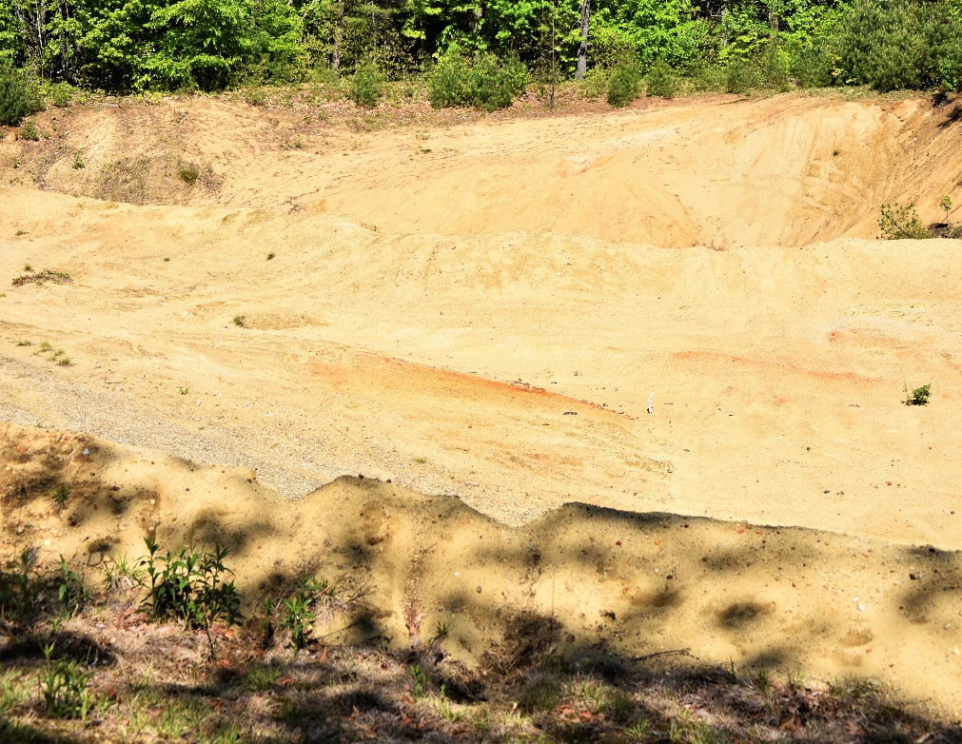
New Boston Highway Department Mining Site

ZONE #4 -UPLAND HARDWOOD
This zone is +/- 13 acres and located on the northern most side of the Sherburne Forest. The topography is slightly sloping to the south and to the wetlands. There are two stands. Stand #5 is primarily Red Oak and stand #6 is Red Maple.
The area is accessible by Cochran Hill Rd. (Class 6) on two sides. The need by wildlife for early successional forest and mast producing tress can be met in this zone. There are Red Oaks in the 14”-18” DBH and Red Maples in the 10’-22’ DBH size range. Both species are in prime mast producing s size.

Early successional forest is very important habitat for a variety of wildlife species, as it provides dense cover and an abundance of food sources. To create this critical habitat, five percent of the basal area is to be harvested using a group selection system on a five (5) year rotation. This silvicultural system removes 5-25 mature trees in small groups resulting in openings 0.25-0.75 acres in size. Some areas in the center of the openings will be sunlit throughout the day, where edges will be mostly shaded. This will result in a variety of species regenerating, including oaks and pine at the center and black birch or maples toward the edges. Groups will be identified and marked by an NBFC forester or another licensed forester, and all trees within that plot shall be removed. This practice will allow for new seedling establishment and sprouting from harvested stems, producing dense cover and a food source for wildlife. Whenever possible, groups will be placed so that vigorous seed producing trees of desirable species are on the borders of harvested groups, providing a source of seeds to establish new regeneration. All cavity trees should be left for wildlife use. Habitat for rabbits may be created from slash generated by removal of any logs, using guidelines established by NH Fish and Game and UNH Extension Service.

GENERAL GUIDELINES

NBFC does not recommend bio-mass whole tree harvesting in general. Slash from any harvest is to be left not more than 2’ high on the forest floor. This practice will create a habitat for wildlife and return nutrients to the soil.
All work in the Sherburne Forest shall be planned by the NBFC, Hillsborough County Forester and a licensed forester, as needed.
Any harvesting shall comply with “Best Management Practices for Erosion Control on Timber Harvesting Operation in NH”, 2004 NH Department of Resources and Economic Development.

All NH laws shall be adhered to RSA 482-A, RSA 227-J, RSA 483-A, RSA 227-J. These RSAs apply to any harvesting in the forest.
NBFC will check and maintain boundary lines every 2 years.
NBFC will mow wildflower fields annually in late fall.
NBFC will monitor Hemlock for Wooly Adelgid and Elongate Scale annually.

FOREST MANAGEMENT ACTIVITY SCHEDULE

GENERAL
- Assemble a work party to clean-up debris that is around the edge of the esker – 2020.
- Construct a bridge over the brook in the southern part of the trail system -2012.
- Construct a wetland viewing area from the top of Kame Terrace-2022.
- Reclaim the sand pit area and seed with wildflowers – (when sand mining operation is complete)
- In 2025, harvest 5% of the basal area in wildlife zone #4.
- In 2030, Harvest 5% of the basal area in wildlife zone #4. Revisit the buffer zone restriction around the sand pit area.
7.) Conduct a small harvest in the wildlife zone #3 in 2030, if approved by the NBFC and the Town of New Boston.

SOILS
The soil range in the Sherburne Forest is very diverse ranging from Windsor which is excessively drained soil (Kame Terrace) to Leicester which is poorly drained (wetlands).
All soils are as below:

Canton - CMC slope of 8-15%, CMD slope of 15-35%
The site index for forest productivity – White Pine – 58, Red Oak – 52
It is a well-drained, stony fine sandy loam, upland glacial till with a low Ph.
Logging operations are best conducted in the dry time of year or winter.
Windthrow hazard is slight.

Leicester – LVA slope 0-5%.
Due to the seasonal highwater table, water tolerant species, such as Red Maple, do best.
Site index for forest productivity – White Pine – 65, Red Oak – 61, Red Maple – 70.
The soil is complex, stony and poorly drained.
Erosion is a concern no logging shall take place in these wetland soils.
Windthrow hazard is severe.

Scituate – STB -slope 3-8%
Moderately well drained soil – stony, fine, sandy loam
Site index for forest productivity – White Pine – 65, Red Oak – 61, Sugar Maple – 55.
Erosion is a concern when logging. Best in the dry time of year or on frozen ground
Windthrow hazard is slight

Windsor – WDC slope 8-15%
Well drained soil – loamy, sand
Site index for forest productivity – White Pine – 57, Red Oak – 52, Sugar Maple- 55

Erosion concerns are low
Windthrow hazard – slight

Paxton – PFC slope 8-15%
Stony, fine sand, loam
Site index for forest productivity – White Pine- 66, Red Oak – 65, Sugar Maple – 75
Erosion concerns – slight
Windthrow hazard – slight
Logging shall take place in dry time of the year

FOREST STAND DATA

All sample plots are 1/10th acre in size. Layout was completed using Garmin Basecamp and field locations were identified using a handheld GPS.
Stand #1
18.7 Acres
This stand is mostly Eastern Hemlock/ White Pine
Eastern Hemlock – Basal area 53 square feet per acre. Estimated saw log board foot per acre – 2307
White Pine – Basal area 25 square feet per acre. Estimated saw log board foot per acre – 3448
Red Oak – Basal area 21 square feet per acre. Estimated saw log board foot per acre – 2665
Red Maple – Basal area 15 square feet per acre. Estimated saw log board foot per acre 673.

Hardwood cords per acre- 3.6
Softwood cords per acre- 7.2

STAND #2
4.5 Acres
This stand is upland hardwood with White Pine/Eastern Hemlock.
Red Oak- Basal area 21 square feet per acre. Estimated saw log board foot per acre 2093.
White Pine – Basal area 21 square feet per acre. Estimated saw log board foot per acre 1400.
Hemlock – Basal area 24 square feet per acre. Estimated saw log board foot per acre 1123.
Hardwood cords per acre – 3.9
Softwood cords per acre – 1.8

Stand #3
2.9 Acres
This stand is predominantly a low land dense hemlock forest.
Hemlock – Basal area 13 square feet per acre. Estimated saw log board foot per acre 125.
White Pine -basal area 13square feet per acre. Estimated saw log board foot per acre – 125.
Red Oak – Basal area 7 square feet per acre. Estimated saw log board foot per acre 305.
Red Maple – Basal area 3 square feet per acre.

Hardwood cords per acre – 1.1
Softwood cords per acre – 16.4

STAND #4
41.4 Acres
This stand is sapling to pole size White Pine. White Pine Weevil damage is present.
White Pine – Basal area 103 square feet per acre. Estimated board foot per acre – 9242.
Hemlock – Basal area 12 square feet per acre. Estimated board foot per acre 215.
Red Oak- Basal area 14 square feet per acre. Estimated board foot per acre 693.
Red Maple – Basal area 24 square feet per acre. Estimated board foot per acre- 935.
Hardwood cords per acre – 4.4
Softwood cords per acre – 5.2

STAND #5
2.5 Acres
This is a Red Oak stand with a small number of Eastern Hemlock.
Red Oak- Basal area 52 square feet per acre. Estimated saw log board foot per acre- 4150.
Eastern Hemlock – Basal area 20 square feet per acre. Estimated saw log board foot per acre – 4090.
White Pine – Basal area – 38 per acre. No trees large enough for saw logs now.
Hardwood cords per acre – 1.7

Softwood cords per acre – 2.1
STAND #6
2.1 Acres
This stand is an upland hardwood forest. The stand is dominated by Red Maple with a mix of White Pine and Beech.
Red Maple – Basal area 109 square feet per acre. Estimated saw log board foot per acre – 4220.
White Pine – Basal area 37 square feet per acre. Estimated saw log board foot per acre – 5850.
Hardwood cords per acre – 5.5.

APPENDIX 1

TIMBER STAND SAMPLE PLOT COORDINATES
All sample plots are 1/10th acre

Plot # Latitude Longitude
1 N42-58.222 W71-43.039
2 N42-58.219 W71-43.073
3 N42-58.213 W71-43.121
4 N42-58.205 W71-43.177
5 N42-58.196 W71-43.228
6 N42-58.189 W71-43.277
7 N42-58.144 W71-43.302
8 N42-58.184 W71-43.321
9 N42-58.231 W71-43.326
10 N42-58.230 W71-43.277
11 N42-48.231 W71-43.218
12 N42-58.236 W71-43.170
13 N42-58.239 W71-43.132
14 N42-58.247 W71-43.082
15 N42-58.300 W71-43.058
16 N42-58.296 W71-43.120
17 N42-58.290 W71-43.175

18 N42-58.284 W71-43.217
19 N42-58.281 W71-43.272
20 N42-58.277 W71-43.305
21 N42-58.272 W71-43.347
22 N42-58.320 W71-43.304
23 N42-58.327 W71-43.304
24 N42-58.333 W71-43.252
25 N42-58.338 W71-43.205
26 N42-58.342 W71-43.154
27 N42-58.350 W71-43.093
28 N42-58.408 W71-43.088
29 N42-58.403 W71-43.151
30 N42-58.400 W71-43.203
31 N42-58.393 W71-43.255
32 N42-58.393 W71-43.294
33 N42-58.443 W71-43.271
34 N42-58.445 W71-43.233
35 N42-58.450 W71-43.180
36 N42-58.461 W71-43.118
37 N42-58.507 W71-43.056
38 N42-58.496 W71-43.134
39 N42-58.492 W71-43.182
40 N42-58.492 W71-43.228
41 N42-58.518 W71-43.260
42 N42-58.538 W71-43.180
43 N42-58.541 W71-43.136
44 N42-58.548 W71-43.064
45 N42-58.595 W71-43.202
46 N42-58.579 W71-43.133
47 N42-58.565 W71-43.177
48 N42-58.561 W71-43.243
49 N42-58.589 W71-43.078
50 N42-58.608 W71-43.150
51 N42-58.627 W71-43.106

