LYDIA DODGE FOREST MANAGEMENT PLAN
239+/- Acres

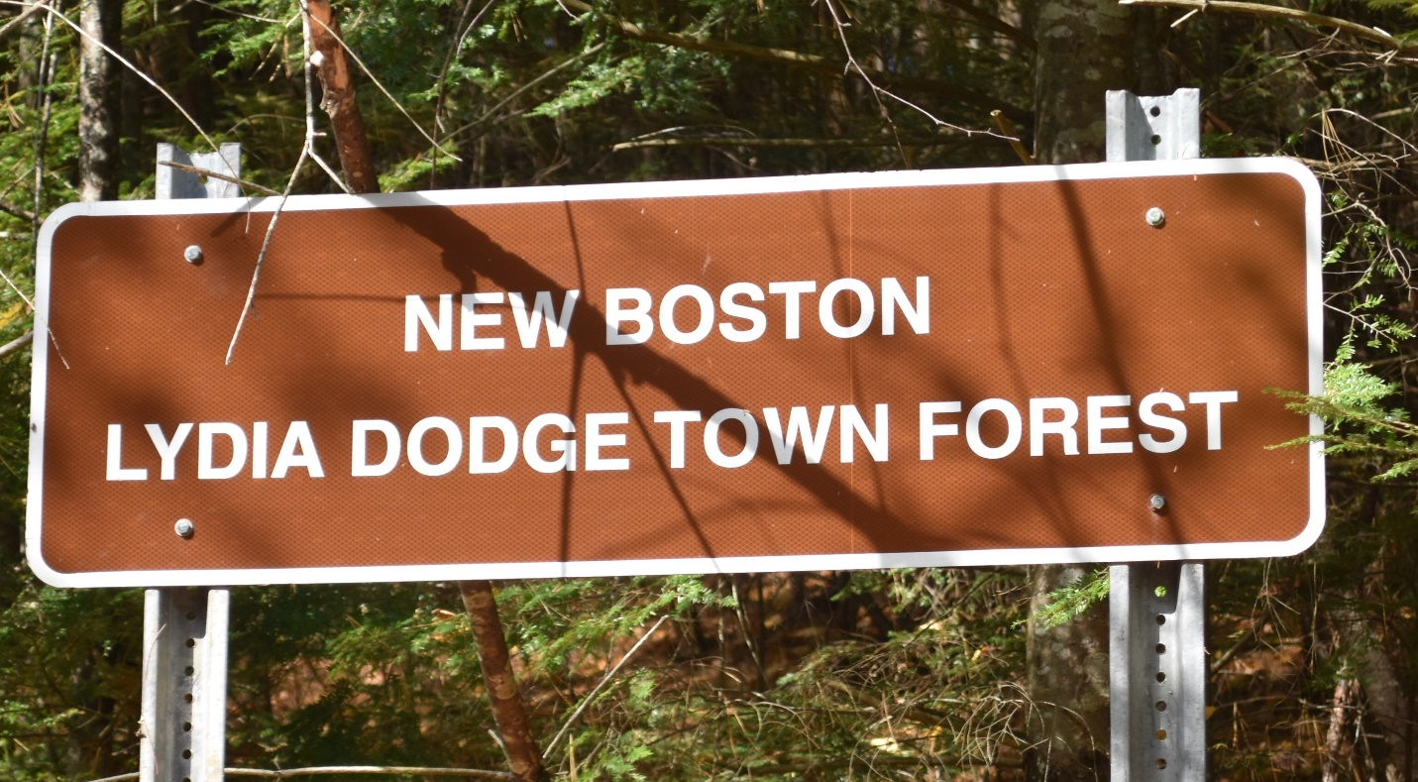
Prepared for: Prepared by:
Town of New Boston Thomas Miller
New Boston, NH 03070 New Boston Forestry Committee

Acknowledgement and Thanks for
Maps and Sample Plot
Data Preparation:
Norman Gagnon, UNH Forestry
Student Intern

TABLE OF CONTENTS
Introduction………………………………….. p.4
Location………………………………………….. p.5
Description…………………………………….. p.7
History………………………………………….. p.9
Piscataquog Land Conservancy Conservation Easement/Management Goals……………………………………………… p.11
Education and Recreation……………… p.13
Invasive Species…………………………………p.14
Natural Communities…………………………p.15
Soils…………………………………………………..p.16
Boundaries and Health…………………….. p.17
Wetlands…………………………………………..p.19
Wildlife………………………………………………p.20
Stands 1 through 6…………………………… p.16
Goal Implementation Criteria…………… p.28
Forest Management Activity Schedule…p.29

APPENDICIES

A. Forest Stand Map
B. New Hampshire Natural Heritage Bureau Report
C. Environmental Services Wetland Map
D. New Boston Trail Map
E. Soil Map
F. Map Unit Legend - Soil
G. Forestland Productivity
H. Sample Plot Locations
I. Sample Plot Data

INTRODUCTION

This Forest Management Plan shall be used as a guide by the New Boston Forestry Committee (NBFC). The plan reflects the objectives of the NBFC at the time of the preparation of the plan in 2020. When changes in site condition, objectives of the NBFC or committee goals occur, the forest management plan shall be reviewed and amended as appropriate. Requirements shall be reviewed and amended as needed to fulfill NBFC goals and maintain New Hampshire Tree Farm status.

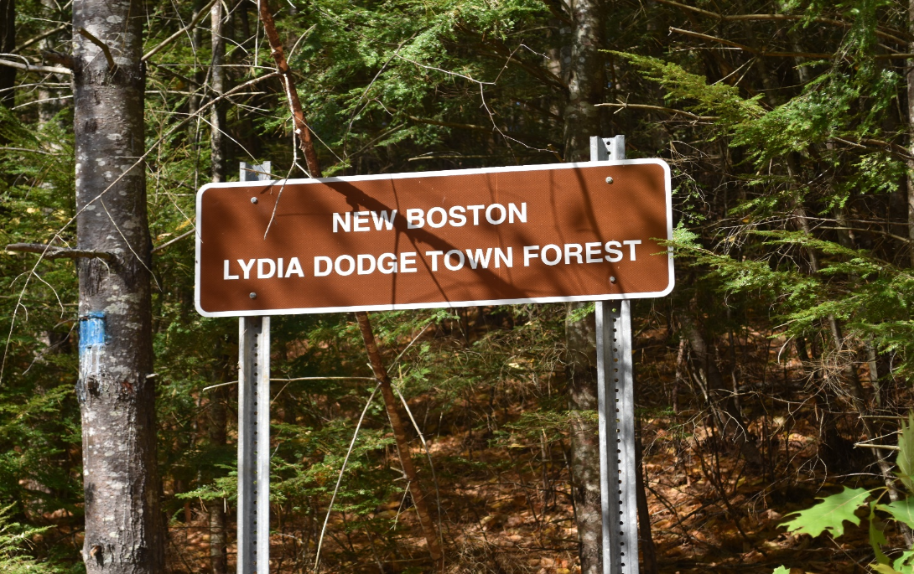

LOCATION and ACCESS

The Lydia Dodge Forest is the property of the Town of New Boston, NH. Tax map number 7, Lot 70, this forest comprises 239.3 +/- contiguous acres.
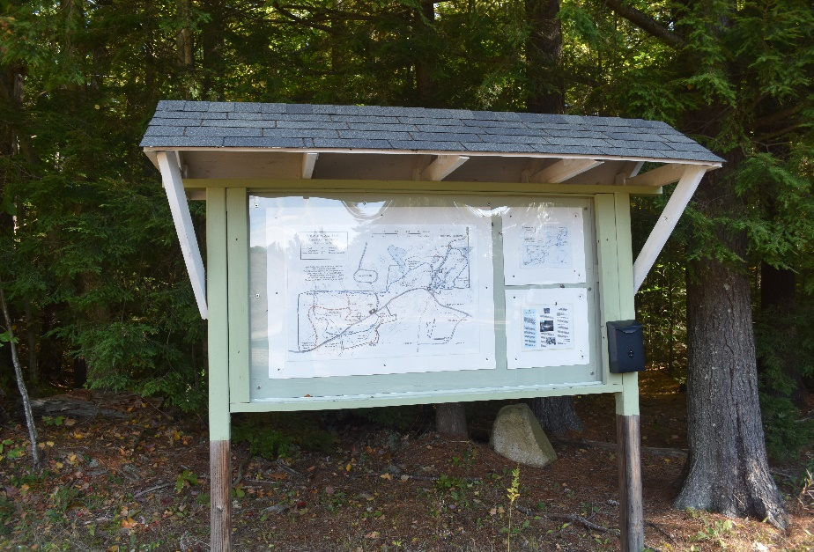
Lydia Dodge Forest is located on Old Coach Road, 2 miles from NH Rt 13. Access to the trail system is at three locations. The main point of entry is the parking lot where a kiosk detailing the trail system is located. This parking lot is east of the New Boston Transfer Station. The second access location is a pull off on Old Coach Road where a designated trailhead sign is located. This access is +/- 500 feet west of Cochran Hill Road, the third access is west of the Sherburne Town Forest parking.

Main access to the Lydia Dodge Town Forest, kiosk in parking area east of NB Transfer Station.

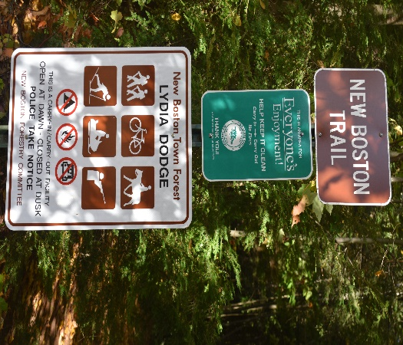
Trailhead marker, parking lot east of the NB Transfer Station

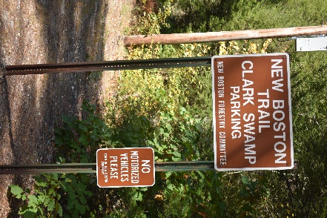 Access location, pull out on Old Coach west of Cochran Hill Rd.

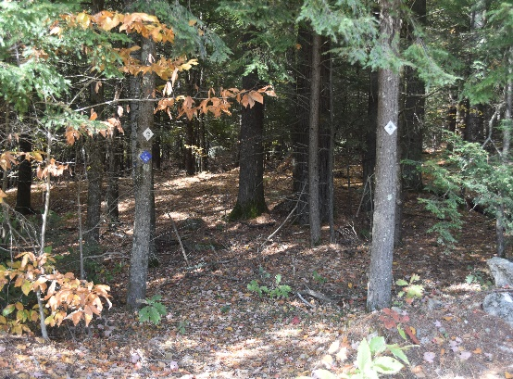 Cochran Hill Rd, west of the Sherburne Town Forest parking.

DESCRIPTION

The Lydia Dodge Forest has historically been referred to as East Lydia Dodge and West Lydia Dodge. The New Boston Transfer Station is the midpoint between the east and west forests. There are 6700 feet of frontage on Old Coach Rd. and 2000 feet of frontage on Cochran Hill Rd. There are existing logging roads in this forest. The Lydia Dodge Forest is a diverse wildlife eco-system with denning areas in the glacial erratic and riparian zones, streams, vernal pools, and the “Clark Swamp”. The upland forest also serves to makes this forest suitable for wildlife habitat. There is evidence that moose, bear, deer, otter, and many species of birds are present in this forest.
The Lydia Dodge Forest represents a mix of hardwood from elm to red oak. Soft woods present in the forest are primarily white pine and hemlock, and a few red spruce trees.
The elevation of the forest is 720 feet at the highest point and 560 feet at the lowest point.
The west side of Lydia Dodge Forest is moderately level with one large wetland, a small stream, and vernal pools. The drainage area terminates at the south branch of the Piscataquog River., passing through conservation land and the Bob Todd Forest. There is a diverse wildlife ecosystem found in the area. This forest is predominantly a white pine/ hemlock forest with some mixed hardwood areas. Mixed hardwoods are deciduous trees including red oak, white oak, red maple, white birch, black birch, yellow birch black ash, white ash, American beech.
The middle section of the Lydia Dodge Forest is north of the transfer station and represents a small area. This area is the transition zone from moderately level topography to hilly glacial erratic washout zone.
The East Lydia Dodge Forest is completely different from the West Lydia Dodge Forest in topography and forest makeup. The topography is steeper sloping from north to south. Large sections of this forest are littered with glacial erratics, making the forest floor rough to navigate. There is also a high-water table. Clark Swamp, a large wetland, and numerous streams and vernal pools are scattered through this forest section. The drainage for this area eventually also terminates at the south branch of the Piscataquog River.

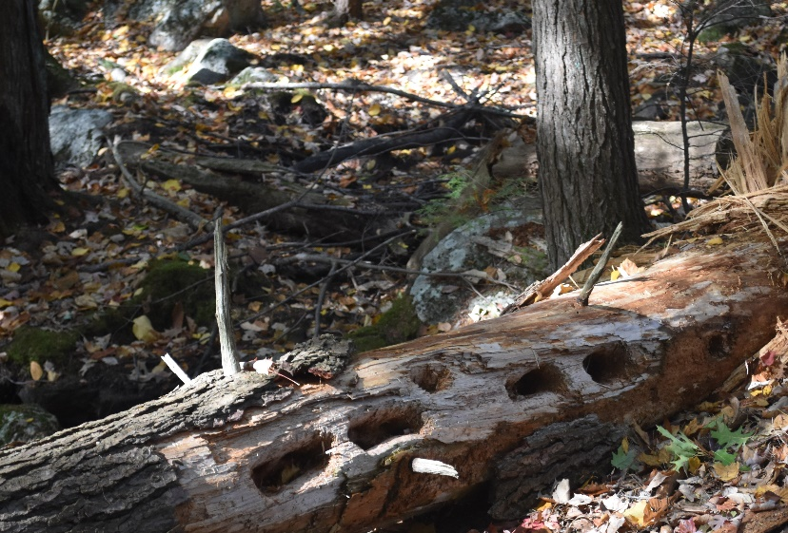
Glacial erratics and possible denning sites.

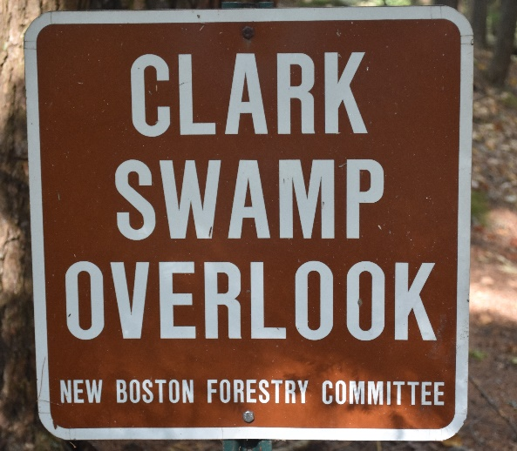
Sign indicating the Clark Swamp Overlook, wetland.

HISTORY
The history of Lydia Dodge Forest is much like that of other forests in the State of New Hampshire. Many forests originated with colonial families in the 18th century and now are reclaimed old agricultural fields.
There is a colonial period cellar hole in the northeast corner of the Lydia Dodge Forest. The family name of the former owners of the cellar hole is unknown currently.
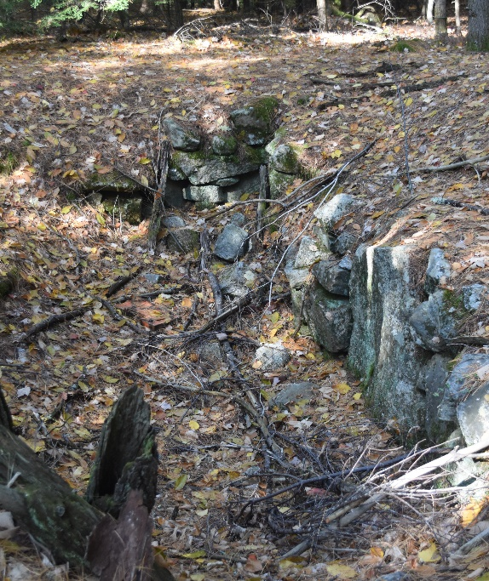
Cellar hole, northeast corner of Lydia Dodge forest.

There are stone walls on boundaries and interior stone walls on this site, indicating that the property was once agricultural land used for livestock and crops.
The Town of New Boston became the owners of this parcel after the death of Lydia Dodge on 9/6/1937 in accordance with her will and testament, probate document #52335 dated 10/18/1938, finalized in the deed transfer.
The New Boston Town Reports provide the following information:
- 1939 – Lydia Dodge Forest was appraised at $1,300.00.
- 1954-1955 – sawlogs and pole sized timber were harvested from the property.
- 1956 – 9,000 BF of timber were removed from the forest for the repair for the Depot Street Bridge and shed repair.
- The Piscataquog chapter of the Future Farmers of America entered a lease agreement with the Town of New Boston from 1956 through the 1960’s. The local FFA chapter was conducting forest management work, including planting, timber stand improvement on a 40-acre section of the forest.
- 1966 the New Boston Forestry Committee was formed to oversee work on the Lydia Dodge Forest.
- 1969 - 303,360 BF of white pine were harvested.
- 1970 – 134,662 BF of white pine were harvested.
- 1973 – 216,000 BF of white pine were harvested.
- 1995 - 190,00 BF of white pine and mixed hardwood were harvested.
- 1997 – The New Boston Trail was constructed by the NBFC under chairman Jon Brooks.
- 1999 – University of New Hampshire (UNH) Forest Resource students’ project was the Wildlife and Forest Survey in the “Eastern” forest.
- 2000 – 16,160 BF of white pine from the “west forest”.
- 2000 – UNH Forest Resource students’ project was the Wildlife and Forest survey in the “west” forest.
- 2003 -2008 – NBFC constructed the trail system in the Lydia Dodge East Forest.
- 2017 – 47,163 BF of red pine were harvested in the Lydia Dodge West Forest, northwest of the transfer station.
- 2020 – A conservation easement was voted on by the Town of New Boston voters to protect the Lydia Dodge Forest into the future. The Piscataquog Land Conservancy (PLC) will be the easement holder.

Piscataquog Land Conservancy Conservation Easement
In April of 2021, a conservation easement was placed on the Lydia Dodge Forest. The Piscataquog Land Conservancy is the holder of the easement. Together with the PLC, the NBFC will work to preserve the soil and water quality, forest and wildlife diversity and habitat, natural communities, historical and scenic qualities that exist on the property. The conservation easement ensures that the property is protected in perpetuity by utilizing the most up to date best management practices for all forestry and recreational related activity.

NEW BOSTON FORESTRY COMMITTEE FOREST MANAGEMENT GOALS

The Lydia Dodge Forest is a multi-use forest. Hiking, horseback riding, hunting, wildlife viewing, and forest product production are some of the uses.
The Lydia Dodge Forest is an important part of a major wildlife corridor. The corridor is comprised of Bob Todd Forest, Sherburne Town Forest, and a conservation easement on the Wheeler and Kachavos lands by the PLC.
The NBFC goal for this forest will be to protect the forest eco-system which includes wetlands, wildlife habitat, forest diversity, and aesthetic value of the forest.
Timber production historically has been a major part of this forest management. The recommendation for silviculture practice is to create an uneven aged stand, including timber stands of three or more age classes, increasing species and size class diversity. Harvesting should be done in patch cuts, creating openings up to a half-acre in size. These openings will help with the regeneration of white pine, red and white oak, provide wildlife habitat and food source.
These patch cuts should be done in areas where the basal area is above 100 square feet per acre. The areas can initially be located using sample plot GPS locations that are above 100 square feet basal area per acre.
Harvest size per event should be kept below 100,000 BF. Harvests will be conducted biennially for the next 8 years; at that point, a timber inventory should be conducted. This practice is to maintain the aesthetic value of the forest. Harvesting near, or along, trails should be done only when basal area or silviculture practices warrant. The number of trees harvested within 50 feet of a trail should be minimal and all slash is to be removed from the trail.
Whole tree harvesting (Biomass), in general, is not recommended except for infestation from diseases, insects, or natural damage from wind or ice storms. Refer to Forest Heath topic for further recommendations. Leaving slabs on the forest floor will replace needed nutrients. Slash should be cut down to no more than 2 feet above the forest floor. The NBFC should consider piling some of the slash to create wildlife habitat.
All work conducted in the Lydia Dodge Forest will be planned by the NBFC, Hillsborough County Forester and a licensed forester, as needed.
The NBFC will conduct forest management activities in accordance with all applicable NH Forest Laws RSA-79 (Timber Tax Law), RSA 227-5 (Timber Harvesting Law), RSA 482-A (Dredge and Fill in Wetlands), RSA 483-B (Comprehensive Shoreline Protection).
NBFC will utilize publications such as “Good Forestry in the Granite State: Forestry Management for NH” (NHDRED, Dec. 2010), and “New Hampshire Best Management Practices for Erosion Control On Timber Harvesting Operations” (Division of Forests & Lands, & University of NH Cooperative Extension” (Dec, 2016). “Uneven-Aged Management of Northern Hardwood in New England” by William B. Leak and Stanley M. Filip, USDA Forest Service Research Paper NH-332 (1975), will be consulted as well.
Furthermore, planning and implementation of forestry operations shall be coordinated with other critical silviculture practices. Such practices shall include maintaining an uneven aged forest as a hedge against the ecological effects of weather, disease, insects, and to increase biodiversity.

EDUCATIONAL AND RECREATIONAL

Recreational trails run throughout the forest. The trail system is 3.3 miles of marked trails. One of the many interesting sites is the “Clark Swamp Overlook”. The view from the overlook is a forest wetland. There are many stream crossings adding to the forest experience. On the Lydia Dodge Forest kiosk at the main trail entrance is a trail map.

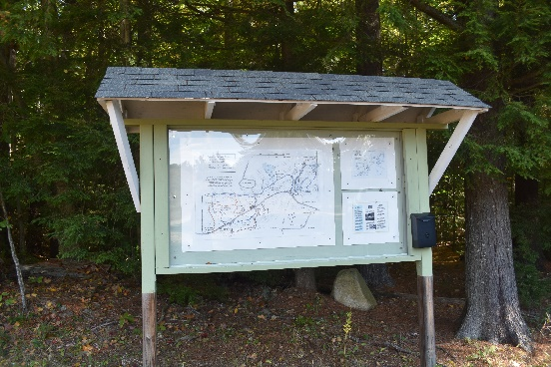
Lydia Dodge Kiosk and trail map

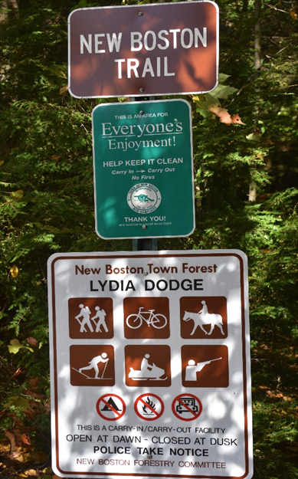

Lydia Dodge signage at main entrance

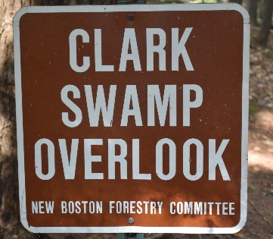Clark Swamp Overlook sign located along the trail

Recreation uses of this forest include hiking, biking, cross-country skiing, snowshoeing, horseback riding, wildlife viewing, and general enjoyment of the aesthetics of the forest. Wheeled motorized vehicles are not permitted in this forest. The trail system covers many parts of the forest and offers a diverse eco-system and geology. The trail system is to be maintained annually, or when needed. The trail and other signs are to be maintained. All bridges or stream crossings shall be inspected frequently and repaired as needed.
The Lydia Dodge Forest is a resource which may be utilized by the New Boston school system for educational purposes. The forest’s various wildlife habitats, diverse plant species and eco-systems can help provide hands-on experiential education for students.

INVASIVE SPECIES
At the time of the preparation of the Lydia Dodge Management Plan, there are no known invasive species identified in this forest.
If invasive species are found in the future, NBFC members or volunteers should remove the invasive by hand or a small excavator. The use of herbicides is not recommended because of the proximity to the wetlands.

NATURAL COMMUNITIES
At this time, there are no known endangered species in this forest as reported by the NH Natural Heritage Bureau (S3). There is a small area of red maple – black ash swamp (see footnote below) in the Lydia Dodge “East”. This community is contained within stand #5. The NH Natural Heritage book, “The Nature of New Hampshire”, Dan Sperduto and Ben Kimball, classifies all ecosystems in NH into distinct natural communities. According to the NBFC evaluation of the property and in consultation with the Sperduto-Kimball book above, the predominant forest species are hemlock-beech-oak-pine(S5). (footnote below).

Footnote S3 – “Vulnerable: At moderate risk of elimination due to restricted range, relatively few examples (generally twenty-one to one hundred occurrences), or vulnerable to elimination because of other factors.” Sperduto, p.309
Footnote S5 – “Secure: Demonstrably common, widespread and abundant.” Sperduto, p. 309

FOREST SOILS

The information on the forest soils was obtained from USDA Soil Conservation Service and NH Agricultural Experiment Station.
After a description of each soil type, a site index number is provided. The soil site index scale is 0-100, where 100 is the best possible soil. The soils that make up the Lydia Dodge Forest are as follows:
Canton Series: Well drained, moderately-rapidly permeable, upland glacial till on slopes 0% to 35%. Canton soils are fine sandy loam. Soil site index rates windthrow and seedling mortality as slight. Best growth potential is managing for white pine (site index 58), red and white oak (site index 52). There are 143.6 acres of Canton soil in this forest.
Hinkley Series: Excessively well drained, found on terraces and wash-out 0% to 35%. Hinkley soils are loamy sand. Soil site index rates windthrow slight with seedling mortality rated severe. Manage for white pine (site index 61), red oak (Site index 49), sugar maple (site index 57). There are 41.4 acres of Hinkley soil in this forest.
There are small areas of the following soil types:
Deerfield: Loamy fine sand. Soil site index slight windthrow hazard and moderate seedling mortality. Site indexes for trees as follows – white pine (65) and red oak (55) do best in these soils.
Leicester – Walpole series: complex stony severe windthrow and seedling mortality. Site indexes – red maple (70), white pine (69), red oak (56).
Pipe Stone: poorly drained soil that is loamy sand, Site index shows that the area has slight windthrow hazard and moderate seedling mortality. Red maple (56).
Windsor: Excessively drained soil that is sandy glacial outwash, and is found with Canton, Deerfield, and Hinkley soils. Site index windthrow is slight and seedling mortality is severe. White pine (57), red oak (52), and sugar maple (55) are the best trees for this soil type.
The remaining soils are wetland soils and are Scarboro and Borohemists. Scarboro soils are stony, mucky, loamy sand. The site index shows severe windthrow and severe seedling mortality. Red maple (50) and white pine (50) are best trees for the soil here.
Borohemists are very poorly drained soils with no site index.

BOUNDARY LINES

The boundary lines in the forest were re-established in 2020 as part of the conservation easement with PLC. All bounds will bear a 2 ½” x 2 ½” aluminum printed signs. Boundary trees are marked with blue paint blaze.
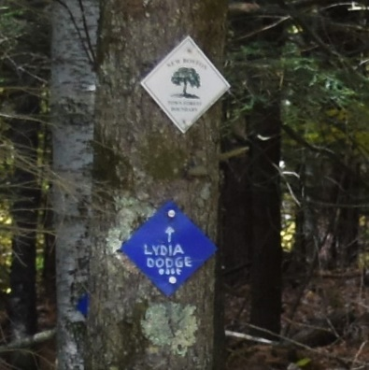 2 ½” square sign along Lydia Dodge boundary

FOREST HEALTH

The beech trees in the Lydia Dodge Forest show signs of Beech Bark Disease. These trees will succumb to the disease over time. This disease progress will also negatively impact seed production and so the seeds that wildlife utilize for food sources will be depleted.
Elm in stand #5 show no signs of Dutch Elm Disease at the present time.
White ash and black ash show signs of Emerald Ash Borer. Currently, about half of the trees in the stand are affected. Eventually, all the black and white ash will succumb to the Ash Borer.
The eastern hemlock and red spruce, at present, do not show signs Hemlock Wooly Adelgid or Elongate Hemlock Scale.
The Bob Todd Forest, just south of the Lydia Dodge Forest, has a small number of trees with Wooly Adelgid and Elongate Scale. There is a strong possibility that Lydia Dodge Forest will become infected by both invasive insects. Due to the large number of hemlocks in the Lydia Dodge Forest, NBFC must determine an appropriate course of action. The USDA publication, “Managing Hemlock in the Northern New England Forest Threatened by Hemlock Wooly Adelgid and Elongate Hemlock Scale” (9/2015) shall be consulted as a guide for management.
The US Forest Service research paper has presented the following as recommendations:
- Do nothing – wait and let nature rule. This approach may not work in Lydia Dodge because of the aesthetic value of the public land.
- Cut the affected trees and chip and cover, or pile and burn the limbs of the trees. This method will require a volunteer or paid workforce.
- Biomass and logging operation – the trees are chipped or logged and sold. The remaining parts of the trees (limbs, branches) are chipped, blown into a closed trailer, and transported to an incinerator. This is the most viable solution.
Should all eastern hemlock be removed, other successional trees like white pine, red maple, aspen, red oak, or white birch, will fill in the areas left behind, creating new habitat and food sources for wildlife.
Because of the proximity to major wetlands, the use of pesticides to control insects and diseases is not recommended.
Other forest health concerns may occur over time. Early detection and rapid response to the issues are important to successful management.
Monitoring the health of the Lydia Dodge Forest shall be completed by the NBFC annually.
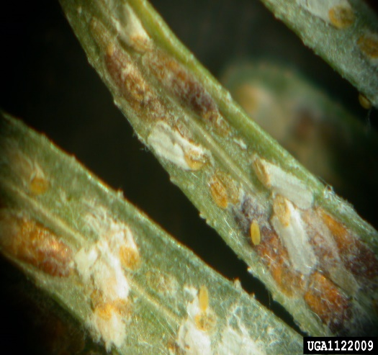
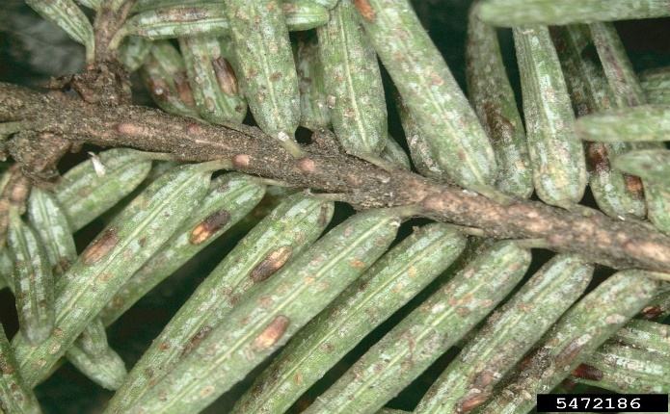
Elongate Hemlock Scale
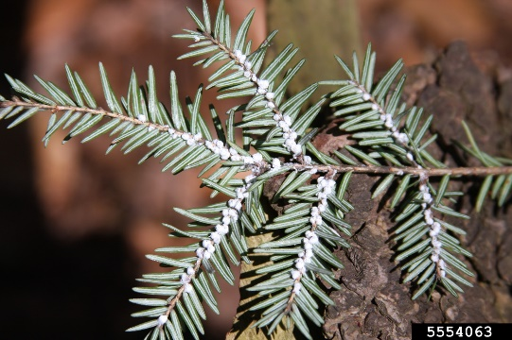
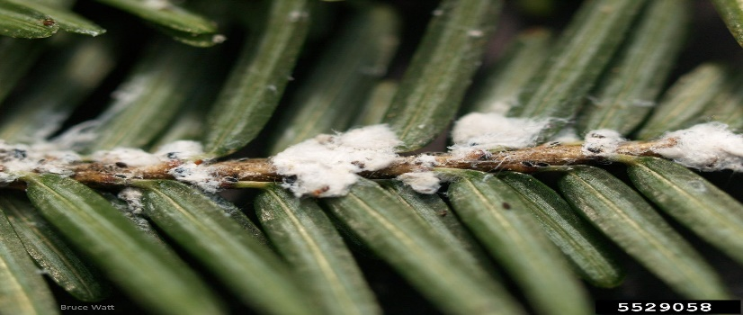
Hemlock Wooly Adelgid

WETLAND
There are 35 acres of wetland soils in the Lydia Dodge Forest. The west side of the forest has a small stream which flows most of the year. This stream leads into a wetland with standing water. The swamp is known as “rich swamp”, having an inlet and an outlet. It is identified in the book “The Nature of New Hampshire”, by D. Sperduto and B. Kimball as a red maple-sphagnum basin swamp. The canopy is dominated by red maple with hemlock present. The edges of the swamp contain highbush blueberries, winterberries, cinnamon ferns, and marsh ferns. This type of ecosystem is listed as S4, meaning apparently secure, uncommon, but not rare. The water from Lydia Dodge passes under Old Coach Rd. and into the Bobb Todd Forest and terminates at the South Branch of the Piscataquog River.
The section of the Lydia Dodge Forest which represents the geographic middle of the forest is north of the NB Transfer Station and has no wetland.
The east side of the Lydia Dodge Forest is a more complex wetland system. Located in the northeast section of the forest is Clark Swamp. There is a hiking trail that borders the wetland with a signed overlook. This is a “rich swamp” with an inlet and outlet. It is also a red maple-sphagnum basin swamp with the same flora and fauna as the westside swamp. The Clark Swamp outlet leads downslope to the south and into another red maple swamp, bordering Old Coach Rd, crossing the road to terminate at the South Branch of the Piscataquog River.
There is another wetland fed from the Clark Swamp. That wetland passes through an area of steep-sided ledges and leads into a red maple-sphagnum basin swamp, leading to a stream that passes through another area of small glacial erratics. This stream area contains a section of trees such as black ash, elm, and black gum. Of interest, this area was noted in the NH Natural Heritage Bureau report as red maple-black ash swamp and is listed as S3, meaning vulnerable-moderate risk of elimination. The water course passes under Cochran Hill Rd. and eventually terminates at the South Branch of the Piscataquog River.
There are numerous vernal pools in this area of the forest.

WILDLIFE

Lydia Dodge Forest is part of a large wildlife corridor which includes two other Town of New Boston Forests and three privately owned parcels which are in conservation easements. The forest is primarily a late successional forest with over 25 acres of wetland and has an abundance of vernal pools.
The forest contains a good mix of hardwoods and conifers. These trees supply wildlife with cover and food. The principle hardwoods are red oak and red maple. Red oak provides hard mast (acorns) and cover to turkeys, black bear, deer, squirrels, mice, bats, blue jays, and pileated woodpeckers.
Red maple produces soft mast (seeds) and cover for fox, raccoons, bats, woodpeckers, wood ducks, owls, and chickadees.
Conifers dominant in this forest are eastern white pine and eastern hemlock. White pine is used by squirrels, hare, bats, fox, and nuthatches. Eastern hemlock supplies the following species with food and cover: squirrels, bats, fox, black bear, wrens, porcupine, owls, blue jays, and nuthatches. These lists are not all inclusive and serve to illustrate biological diversity in this forest.
During the timber cruise in the winter of 2019-2020, the tracks of the following mammals were noted: deer, turkey, otter, raccoon. In the spring of 2020, red newts and spotted salamanders were found throughout the forest.
The NBFC recommendations for management will serve to protect the habitat and increase diversity in this forest, benefitting wildlife. The silviculture practices of creating uneven aged stands by using small patch harvesting will help to build areas of early successional forest. Early successional forests provide cover and food resources for an array of species.
Another recommendation is to retain cavity trees used by wildlife for varied purposes. Large unmarketable trees should be girdled to create future cavity trees.
Slash should be left in the forest to return nutrients back to the forest floor and provide a habitat for amphibians. Piling slash in a few locations will provide cover for wildlife. 100’ buffer zones around all wetlands should be maintained during tree harvests. Vernal pools should be located and marked in the springtime before logging operations begin. Skid trail crossings and dropping of trees shall not be permitted in the vicinity of vernal pools.

TIMBER STANDS

A complete inventory of the Lydia Dodge Forest was conducted during the winter of 2019 to spring of 2020. Stand inventory measured all trees 6” and larger. The total plots numbered 108. No sampling took place in the wetlands because there was no access. Plot size was 1/10th of an acre. Plot grid spacing was between 250’ and 350’. This grid layout was completed on Garmin Base Camp computer program, then loaded onto a handheld GPS unit. Sample plot information recorded includes species, DBH, basal area, volumes of BF, and cords. Smallest acceptable tip diameter was 8”. The tip diameter, number of logs, and Diameter Breast Height (DBH) were used to compute board footage. There are six timber stands within this forest.

Stand #1 (see appendix)
This stand is mostly level to moderately sloping. The trees are predominantly white pine, with a mix of red pine, hemlock, red maple, and red oak. There are 31.1 acres in this stand. Sample plot numbers from GPS layout are 14, 15, 16, 17, 18, 19, 20, 21, 22, 23, 35, 36, 37, 38, 39, 40, 53.
Average tree diameter in this stand is as follows:
- White pine - 17”
- Red pine- 15”
- Eastern hemlock- 10”
- Red maple- 8”
- Red oak- 7”
Basal area average per acre:
- White pine- 93 per acre
- Red pine- 38
- Eastern hemlock- 26
- Red maple- 15
- Red oak- 9
The total basal area of all species is 181 square feet per acre.

Trees per acre average in stand #1:
- White pine- 66 per acre
- Red pine- 34
- Eastern hemlock- 42
- Red maple- 32
- Red oak- 22
Total average per acre is 147 trees.

Estimated cordwood volume in stand #1:
Hardwood- 123 cords
Softwood- 182 cords

Estimated lumber board footage in stand #1:
- White pine- 423,636 BF
- Red pine- 46,265 BF
- Eastern hemlock- 31,850 BF
- Red maple- 11,891 BF
- Red oak- 640 BF

Stand #2 (see appendix)

Stand #2 is an early successional forest comprises mostly eastern white pine saplings. The overstory is made up of eastern white pine as a seed source. The other components are seedling and sapling sized eastern hemlock that are very dense. There is a mixed hardwood component of red oak and red maple. The size of this stand is 26.5 acres. Sample plots from GPS layout are 12, 13, 24, 25, 26, 32, 34.
Average tree diameter in stand #2:
- Eastern white pine- 17”
- Eastern hemlock- 9”
- Northern red oak- 11”
- Red maple- 10”
Average basal area:
- Eastern white pine- 40 square feet per acre
- Eastern hemlock- 58 square feet per acre
- Northern red oak- 21 square feet per acre
- Red maple- 9 square feet per acre
Total of all species is 128 square feet per acre.
Number of tree species per acre:
- Eastern white pine- 23
- Eastern hemlock- 90
- Norther red oak- 22
- Red maple- 22
Estimated cords in stand #2:
Hardwood- 97 cords
Softwood- 263 cords

Volume of marketable logs in stand #2
- Eastern white pine- 105,583 BF
- Eastern Hemlock- 55, 196 BF
- Northern red oak- 25,818 BF
- Red maple- 4,353 BF

Stand #3

The total area of stand #3 is 12.8 acres. This stand is a red maple swamp, containing no marketable timber. The stand is most valuable for wildlife. No sample plot information was achieved because of standing water.

Stand #4

This stand totals 80 acres. The following are the GPS plot numbers sampled: 10, 11, 27, 28, 29, 30, 31, 32, 42, 43, 44, 45, 46, 47, 48, 49, 50, 56, 57, 58, 59, 60, 61, 62, 63, 64, 65, 66, 69, 71, 72, 73, 74, 75, 76, 77, 78-A, 79, 80, 81, 82, 83, 84, 85, 86, 91, 92, 95, 90-A.
Eastern white pine is the major species in stand #3. The stand is an uneven age stand, having all classes, from seedlings to large seed source trees. There is a component of red oak and red pine throughout the stand. There is also a small grouping of red spruce.
Stand #4 tallies are as follows:
Average diameter of trees:
- Eastern white pine- 20”
- Eastern hemlock- 12”
- Northern red oak- 12”
- Red maple- 11”
- Red pine- 12”
- Red spruce- 10”

Basal area average per acre:
- Eastern white pine- 92 square feet per acre
- Eastern hemlock- 57 sq. ft per acre
- Northern red oak- 19 sq. ft per acre
- Red pine- 45 square feet per acre
Total of all species is 205 square feet per acre

Trees per acre average:
- Eastern white pine- 45
- Eastern hemlock- 55
- Northern red oak- 19
- Red maple- 47
- Red pine- 5
- Red spruce- 25
Total trees per acre average 165
Stand #4 estimated cordwood volumes:
Hardwood- 468 cords
Softwood- 646 cords

Estimated volume of marketable sawlogs:
- Eastern white pine- 927,525 BF
- Eastern hemlock- 124,432 BF
- Red maple- 76,896 BF
- Northern red oak- 37,140 BF
- Red spruce- 2,893 BF
- Mixed hardwoods (white and black birch, white oak, white ash)- 14,352 BF

Stand #5

This stand contains 60.3 acres. The GPS plot numbers are 87, 88, 97, 98, 103, 105, 106, 107, 108, 112, 113, 114, 116, 119, 120, 122, 123, 124, 125, 127-A, 111-A, 128, 129, 130, 131, 132, 133, 135, 136, 137, 138, 139.
Because of the highwater table and hydraulic soil in this stand, the trees are predominantly a mix of hardwood, with an abundance of eastern hemlock. There is an area of unique hardwoods, such as American elm, black ash, basswood, and black gum. (see sample plots #132, 134).
Stand #5 tallies are as follows:
Average tree diameter:
- Eastern white pine- 16”
- Eastern hemlock- 10”
- Red maple- 9”
- Red oak- 15”

Basal area average:
- Eastern white pine- 34 sq. ft per acre
- Eastern hemlock- 69 sq. ft per acre
- Red maple- 27 sq. ft per acre
- Red oak- 34 sq. ft per acre
Total of all species is 164 sq. ft per acre

Trees per acre average:
- Eastern white pine- 23 per acre
- Eastern hemlock- 110 per acre
- Red maple- 52 per acre
- Red oak- 24 per acre

Estimated cordwood values for stand #5:
Hardwood- 704 cords
Softwood- 656 cords
Estimated volume of marketable sawlogs:
- Eastern white pine- 149,468 BF
- Eastern hemlock- 176,923 BF
- Red maple- 21,444 BF
- Red oak- 114,513 BF
- Mixed hardwood (American beech, black birch, white birch, white oak)- 17,035 BF

Stand #6

Stand #6 is 8.3 acres in size and has GPS plots #142, 144.
This stand is a small strip of white pine and the soil is conducive to growing white pine. This are is elevated above the highwater table found in stand #5.
Average tree diameter:
- Eastern white pine- 18”
- Eastern hemlock- 12”
- There is a small amount of Northern red oak, average diameter of 7” and red oak average diameter of 6”

Basal area:
- Eastern white pine- 144 sq. ft per acre
- Eastern hemlock- 50 sq. ft per acre
Trees per acre average:
- Eastern white pine- 80
- Eastern hemlock- 60
Estimated cordwood volumes in stand #6:
Hardwood- 20 cords
Softwood- 40 cords
Estimated volume of marketable sawlogs:
- Eastern white pine- 165,211 BF
- Eastern hemlock- 23,987 BF

GOAL IMPLEMENTATION CRITERIA

The Lydia Dodge Forest is diverse in many ways; wildlife, soils, hydrography, and many tree species are among the features. The goals are to maintain diversity and to improve timber marketability and wildlife habitat. The recommendations are as follows:
- Keep harvesting operation total removal under 100,000 BF per contract.
- Patch cuts of are to ½ acre or less., thereby creating an uneven aged forest for the benefit of wildlife and continuous crop rotation.
- Preserve the aesthetic value of the forest.
- Biennial harvesting – NBFC has a $50,000 cap on funds in the forestry account. By harvesting biennially, this account will be maintained at a proper level.
- Use sample plot GPS coordinates to locate high basal areas to be harvested first. Recommendations from “Leek and Lamson 1999 revised White Pine Stocking Guide for Managed Stands USDA”, also “Leek, Solomon, and Debald 1987 Silviculture Guide for Northern Hardwood Types in the Northeast, Forest Service” indicate that white pine basal area of 120 square feet per acre and mixed hardwood of 100 square feet per acre, is the goal. Any basal area over these amounts ought to be removed. The use of harvesting maximizes growth potential and creates a healthy genetically superior forest.
- Preserve at least 2 mast trees per acre for wildlife. (Mast trees are red oak, white oak, beech, red maple)
- Harvests of stands #1, #2, #4, #6 may be done during the dry time of the year, June, July, and August, or during the winter with frozen, snow-covered ground. Summer logging benefits white pine seedlings if the soil duff layer is disturbed during logging.
Stand #5 will require frozen and snow-covered ground before harvesting. Monitor for wheel ruts and soil erosion in skid trails. All operations should be suspended if erosion or rutting occurs until the ground conditions are more suitable.
- All slash shall be left on the forest floor and looped to a height of two feet above the ground. This practice will ensure that vital nutrients are returned to the soil.
- Biomass harvesting silviculture practices should only be used in the case of a salvage harvest operation due to insect, disease, or weather event.
- Wetlands and vernal pools must be protected.
- Harvesting locations and patch cut size must consider recreational uses.

FOREST MANAGEMENT ACTIVITY SCHEDULE

2021- Set up Eastern Hemlock Elongate Scale and Wooly Adelgid sample plots. Wooly Adelgid
and Elongate Scale must be monitored annually in addition to the below listed tasks.
Open viewing area to Clark Swamp. This viewing area is to be checked annually.

2022- Harvest total of 100,000 BF of white pine and mixed hardwood

2023- TSI work on white pine.

2024- Harvest total of 1000,000 BF of white pine, eastern hemlock, and mixed hardwood.

2025- TSI work on mixed hardwood and white pine.
Harvest low quality hardwood for firewood and pulp if markets permit.

2026- Repaint boundary lines as needed.

2027- Harvest total of 100,000 BF of eastern hemlock, white pine, and mixed hardwood.

2028- Timber cruise total forest, using existing sample plot GPS locations. Check for growth
rates and forest health.

