NH TREE FARM MANAGEMENT PLAN
COLBY FOREST
10+/- ACRES
Prepared For:
Name: Town of New Boston
Address: 7 Meetinghouse Hill Rd.
PO Box 250
New Boston, NH 03070
Phone: (603) 487-2500
Prepared by: New Boston Forestry Committee

The following plan outline has been formatted to assist the New Boston Forestry Committee in preparing an acceptable Tree Farm Plan to include the 2010-2015 Standards of Sustainability for Forest Certification.

__________________________________________ _________________________________
Signature(s) of Owner(s) Signature of Inspecting Forester
____________________________________ _____________________________
Date Date

Colby Forest Management Plan

Table of Contents
- Location and History of the Colby Forest
- New Boston Forestry Committee Goals
- Soils, Boundary Lines
- Endangered Species, Health
- Wetlands, Wildlife, Access, Recreation
- Management of Stands, Stand #1
- Stand #2
- Stand #3, Goal Implementation Criteria
- Forest Management Activity Schedule

Appendices

Basal Area and Board Foot Estimate

- Stand #1 (Sample plots #1,2,3)
- Stand #2 (Sample plots #4 and part of #3)
- Stand #3 (Sample plots #5 and 6)
- NH Natural Heritage Bureau Report

THE COLBY LOT

Location, History and Character
The Colby Lot is a ten (10) contiguous acre lot located in the Town of New Boston designated as lot 2-118 on the town’s tax map. Initial access to the Colby Lot is achieved by taking the Lull Road Extension of NH Route 77. Access to the interior of the lot is via a Class 6 section of the Lull Road Extension which proceeds up a steep grade. There is parking on an old logging landing. The property length on this side of the lot is approximately 500 feet. Additional access can be gained via 1100 feet of Class 6 road on Dodge Road. This access is through private property. There is no trail system on the lot, nor is any being planned. The notable manmade feature on the lot is a stone wall on the eastern and southern boundary that may have served to divide pasture land in the nineteenth century. The Class 6 roads are a reminder of New Boston history.

The Colby Lot has an interesting history similar in character to much of New Boston’s native lands. From the mid nineteenth century until after World War II, it was pasture land until regrowth occurred as agriculture in New Boston began to decline. In 1975 the land was taken over by the Town of New Boston due to non-payment of property taxes and placed under the care of the New Boston Forestry Committee. In 1998 the New Hampshire Hillsborough County Forester completed a management plan, followed in 1999 by a selective cut as well as some Timber Stand Improvement (TSI) work. In 2000 lot boundaries were marked by small signs and in 2016 a compass and tape survey were executed, and a map was drawn up for working files. In late 2016 several small growth plots were marked by the Committee for monitoring and management purposes. In April of 2021, a conservation easement was placed on the property.

The sample plots themselves were six (6) in number and 1/10 of an acre in size. Species inventory included any tree over six (6) inches in diameter and significant note was taken of all undergrowth in each plot. Stocking levels varied greatly between stands.

Piscataquog Land Conservancy Conservation Easement
In April of 2021, a conservation easement was placed on the Colby Forest. Piscataquog Land Conservancy is the holder of this easement. Together with the PLC, the NBFC will work to preserve the soil and water quality, forest and wildlife diversity and habitat, natural communities, historical and scenic qualities of the property. The conservation easement ensures that the property is protected in perpetuity by utilizing the most up to date best management practices for all forestry and recreational related activity.
New Boston Forestry Committee Goals
The New Boston Forestry Committee (NBFC) is seeking to manage the Colby Forest as an area for wildlife and a sustainable forest by practicing uneven stand silviculture. The goal for the NBFC is to have three (3) or more age classes of trees. Increasing species and size class diversity within the stands will help preserve this forest into the future.

NBFC recommends a blend of group selection and single tree selection harvesting to create openings of ¼ acre and removing clumps of mature or defective trees to facilitate regeneration of the White Pine and Red Oak, the predominant species in stands #1 and 2. The predominant species in stand #3 is Hemlock.

Uneven stand will provide market diversity. Harvesting cycles may be changed due to insect attack, disease, ice damage, drought or declining markets. Uneven stands are self-sustaining. These methods should protect the New Boston Town Forest against market changes and provide diversity in wildlife habitat. Caution must be exercised when harvesting to ensure that existing regeneration is not damaged.

NBFC recommends that Biomass whole tree harvesting be avoided in this forest, thus ensuring that maximum nutrients will be returned to the soil. This practice will also create habitat for wildlife. The slash will protect regeneration of White Pine and Red Oak. More specifically, the Forestry Committee will conduct its management activities in compliance with all applicable New Hampshire Forest Laws, RSA-79 (Timber Tax Law), RSA 227-J (Timber Harvesting Laws), RSA 482-A (Dredge and Fill in Wetlands), and RSA 483-B (comprehensive Shoreline Protection). It will also employ best management practices for erosion control on timber harvesting operation as recommended by the New Hampshire DRED and the University of New Hampshire Cooperative Extension Service in 2000. Furthermore, planning and implementation of forestry operations shall be coordinated with other critical silviculture practices. Such practices will include maintaining an uneven aged forest as a hedge against the ecological effects of weather and disease and to increase biodiversity. As guidance documents for this endeavor we will use such publications as “Good Forestry in the Granite State: Forestry Management for NH” (NHDRED, Dec. 2010), and “New Hampshire Best Management Practices for Erosion Control On Timber Harvesting Operations” (Division of Forests & Lands, & University of NH Cooperative Extension. Dec, 2016). “Uneven-Aged Management of Northern Hardwoods in New England” (Leak, W. and Filip, S. USDA Forest Service Research Paper NH-332, 1975) will be consulted as well.
All work on the Colby Forest will be planned by the NBFC, Hillsborough County Forester and a NH Licensed Forester as needed.

Soils
The Colby Forest soil type is Chetfield/Hollis CSC. The average slope is eight (8) to fifteen (15) percent. Bedrock depth is twenty (20) to forty (40) inches and erosion hazard is relatively slight as is the risk of wind throw. Seedling mortality is also slight due to favorable conditions. With a site index of seventy (70) for Red Oak and sixty-five (65) for White Pine.

Boundary Lines
Boundary lines will be maintained by the NBFC. The lines shall be painted every five (5) years.
Endangered Species
See Appendix enclosed for findings from NH Natural Heritage Bureau. Contact with NH Fish and Game may be required before harvesting forest products. NH Fish and Game telephone is 603-271-6544.

Natural Communities
After review of the book “The Nature of New Hampshire” by Dan Sperduto and Ben Kimball 2011, the Colby Forest is most aligned with the Hemlock-Beech-Oak-Pine classification, ranked S5, Secure: Demonstrably stable, common, and widespread. (Sperduto, pg. 309).

Health
Tree quality and stand health are high within the dominant species. Little to no problems are evident from pathogenic organisms.
Monitoring for Woolly Adelgid and Elongate Hemlock Scale shall be done yearly. If either parasite is identified, action shall be taken. See Management of Forest stand #3, page 8, top. 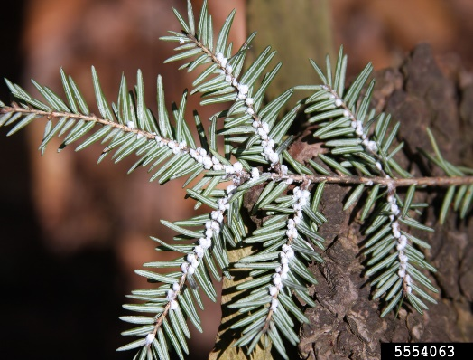 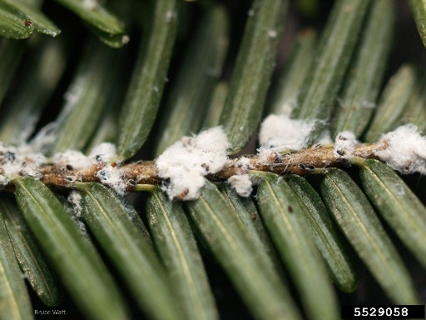 Hemlock Woolly Adelgid

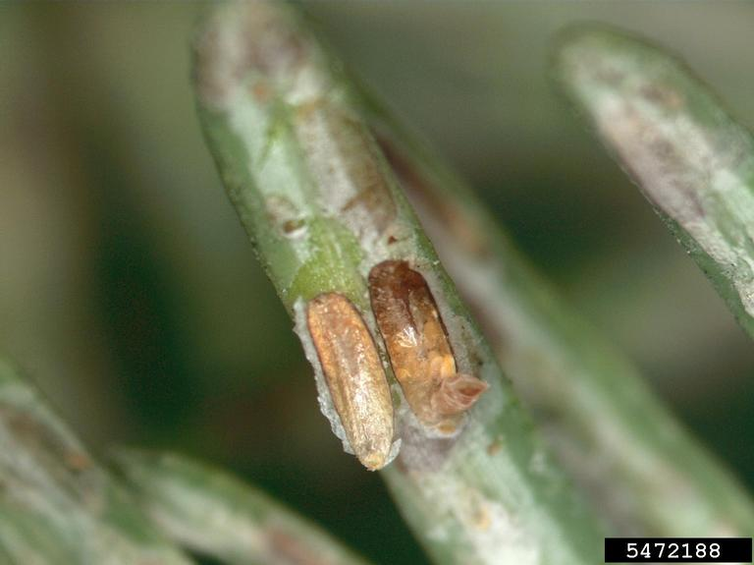
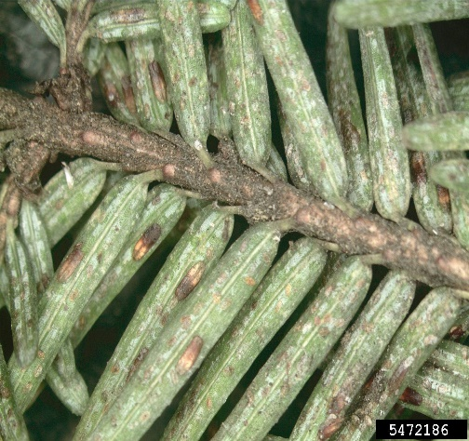
Elongate Hemlock Scale

Wetlands
This forest has no wetlands. The Colby Lot is an upland barrier forest to Still Pond. Logging trails and landings will be laid out to protect against erosion.

Wildlife
The Colby Forest has a dual purpose as a habitat for wildlife and the trees are to be used for forest products.
Within the 10+/- acres, there are Red Oak trees at the prime size and age for acorn production. Stand #3 is a wintering yard for white tail deer. Maintaining this forest as an uneven aged forest will provide habitat for diverse species of wildlife.
Cavity trees and snags shall be left to provide shelter for species such as woodpeckers, chickadees, tufted titmice, squirrels, owls and bats. Leaving slash after harvesting creates dens for small and medium sized animals.

Access
The accesses to this forest are through private property and a Class 6 road. The Class 6 road will need upgrading to render it passable for logging equipment. If the private access must be used, a written agreement with the property owner will be required.

Recreation
The forest has no trails and there are no plans for any to be built. This forest is used by hunters in season. After the forest is harvested, the skid trails may be used for public access.
Because of the small size of this forest and the presence of varying stands, the opportunity exists for organized public walks in the forest to educate the public on forest management practices.

Management of Forest Stands
Colby Forest is comprised of three (3) stands with different tree structures. The following are descriptions of each stand and NBFC recommendation for each stand.
Stand #1
Stand #1 is 4.9+/- acres in size and has predominantly Red Oak in the overstory. White Pine is in the understory. The Red Oak average basal area is 64.2 square feet per acre. There are 36.6 trees per acre. The DBH range is 14” to 22” with a few Red Oak in the understory in the seedling size. White Pine understory is primarily sapling size, DBH 1”-4”. Seedlings are mixed in, as well. There are also Pole sized trees in the understory; White Pine, 5”-11” at DBH. This still will require time to achieve an uneven stand.
The Red Oak basal area is within the acceptable range for an uneven stand. The target range is 70-80 square feet. Red Oak mast production is at the maximum.
At this time (2018) Red Oaks are not to be harvested until the basal area per acre exceeds 80 square feet per acre. When this occurs, mast production will also begin to drop. Harvesting the large Red Oak shall be accomplished in a manner to limit damage the understory, always leaving some Red Oak mast trees for wildlife.
The understory is primarily White Pine, with a few Red Oak. TSI work should be performed now. When thinning the understory, genetically superior stock shall be released. This stock will demonstrate superior growth and vigor. Remove only enough of the understory to allow the selected trees to grow without competing vegetation. TSI shall take place over many years to release trees so that they may develop to their full potential and allow for natural pruning.

Stand #2
This stand is 2.6+/- acres in size and predominantly White Pine. Sizes range from 6”-28” at DBH. The average basal area per acre is 101.7 square feet. Sample plot #4 has a basal area of 160.7 square feet per acre.
NBFC recommends harvesting White Pine near sample plot 4 to remove a sufficient number of trees to bring the stand to an average basal area of 120 square feet or below per acre. Currently, sample plot 4 has an average basal area of 160.7 square feet per acre. Growth ring samples shall be taken on a few trees with less than 12” DBH to determine growth rate. Under performing trees shall be thinned or removed.
Harvesting shall be accomplished using a blend of single tree and group selection. Care should be taken to avoid high grading when selecting for harvest. Remove enough trees to create suitable areas for regeneration by removing small clumps of trees or selecting small plots. The goal is to produce an uneven aged tree stand of high quality with good vigor.
This management practice for Stand 1 and stand 2 should produce product for harvest on a 20-year cycle.
Stand #3
Stand #3 is comprised of Eastern Hemlock and is 2.5 +/- acres. There is an average of 85 trees per acre, with a size range of 7”-28” at DBH.
Stand #3 is to be left as is for wildlife management purposes. This stand meets all the requirements of a winter deer yard.
Woolly Adelgid and Hemlock Elongate Scale are not present currently. It is to be noted that these parasites have been found in other areas of New Boston, so it may be assumed that this stand must be checked annually to monitor for both parasites.
If Woolly Adelgid or Hemlock Elongate Scale is found even on a single tree, that tree or small area of trees are to be cut down. The foliage is to be burned. Check with the New Boston Fire Department for the appropriate permits. If the entire stand becomes infested, the NBFC recommends a salvage cut to remove all marketable trees. Care must be taken to arrest the spread of these diseases to neighboring parcels.

Goal Implementation Criteria
All forestry operations shall be planned by the NBFC, assisted by the New Hampshire Hillsborough County Forester and, if necessary, a licensed New Hampshire Forester.
Harvesting operations will be limited to the following parameters:
- Small mechanical logging equipment to limit soil damage.
- Bio- mass tree harvesting is not recommended for the Colby Forest.
- Slash should be left on the forest floor and cut down to a height of less than 2 feet. Leaving slash on the forest floor will help to decrease soil erosion and protect seedlings from temperature extremes. The nutrients from slash will return to the soil. There are micro-habitats created for small mammals, reptiles and birds.
- Use of herbicides or pesticides is not permitted.
- Timber Stand Improvements (TSI) should be accomplished by selecting the most vigorous trees and those that appear to be genetically superior. During the harvest caution shall be exercised to avoid damage to existing seedlings and other trees.
- The market price of various species of timber shall be considered carefully before any harvest takes place.
- Harvesting will be conducted in the winter or at a dry time of the year, notably July, August, September.
- Public – The forest is owned by the Town of New Boston. The forest will be open to the public during any harvesting operations. There are many educational opportunities before, during and after harvesting operations to demonstrate forest management practices.

Forest Management Activity Schedule

Stand #1
YEAR Treatment
2018 TSI- Red Oak and White Pine seedlings
2019 Monitor stand and up-grade Class 6 road
2020 Paint Forestry Boundary Lines
2021 Monitor stand
2025 Check basal area for growth rate, TSI on understory may be required,
Paint boundary lines
2028 Check basal area on Red Oak. May require Red Oak harvest

Stand #2
2018 Check growth rate on pole sized White Pine
2019 Harvest White Pine in areas of basal area over 120 square feet per acre
2020 Monitor stand
2025 Check stand for basal area stocking
2028 Harvesting may be required

Stand #3
2018-2028 Check stand for Woolly Adelgid and Hemlock Elongate Scale. If found,
act as previously outlined in the plan.

